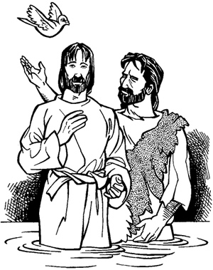
Copyright © Sermons4Kids, Inc.
May be reproduced for Ministry Use
Children’s Worship Bulletin

The Lord's Baptism

Mark 1:1-12

St. Paul’s UCC
301 W. Penn Avenue
Robesonia, PA 19551
610-621-5770

Each number represents a letter of the alphabet. Substitute
the correct letter for the numbers to reveal the coded words.

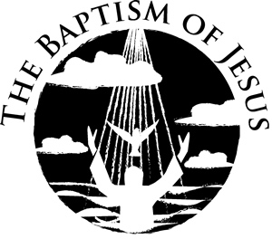

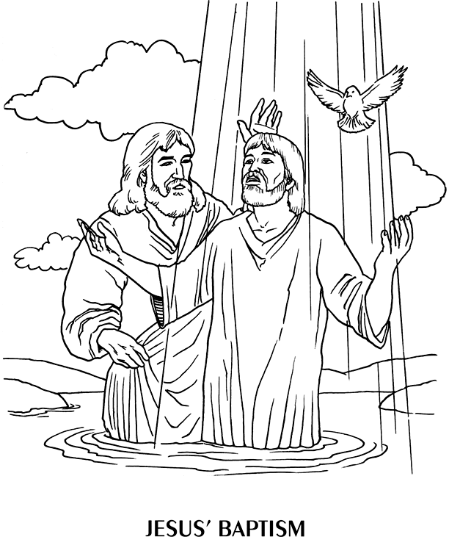

From BibleStoryCard Learning System(tm) Coloring Book © 1996
Wesleyan Publishing House. Used by permission. Additional
BibleStoryCard resources available by calling 1-800-493-7539
or visiting online http://www.parable.com/wph/group_1052.htm

