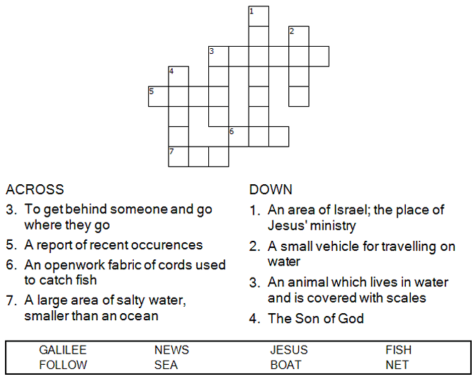

Copyright © Sermons4Kids, Inc.
May be reproduced for Ministry Use

Children’s Worship Bulletin

Following the Leader

Mark 1:14-20

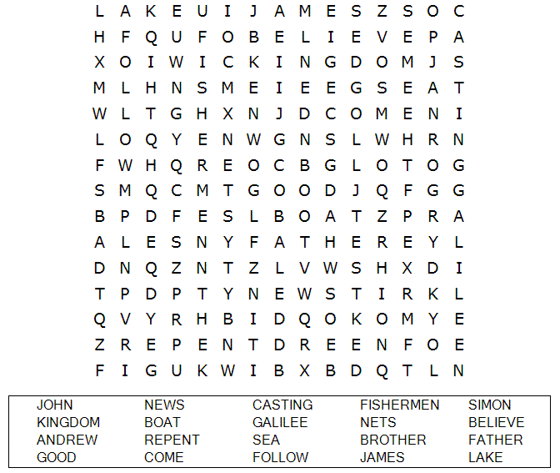
St. Paul’s UCC
301 W Penn Avenue
Robesonia, PA 19551
610-621-5770

Connect the dots to complete the picture.

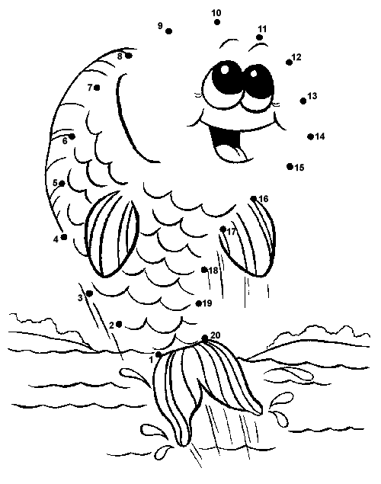

Jesus called out to them, Come, follow me, and I will show you how to fish for people.
Mark 1: 26 (NIV)

Can you find your way through the maze?
