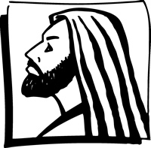
Copyright © Sermons4Kids, Inc.
May be reproduced for Ministry Use
Children’s Worship Bulletin

Who Is in Control?

Mark 1:21-28

St. Paul’s UCC
301 W Penn Avenue
Robesonia, PA 19551
610-621-5770

Choose the word that best matches the definition.



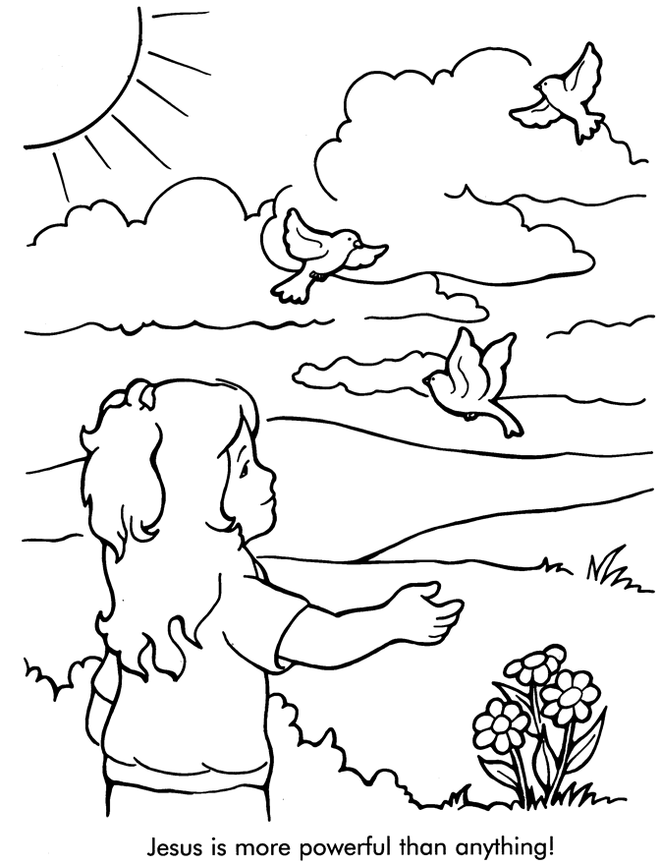
From Thru-the-Bible Coloring Pages © 1986,1988 Standard Publishing.
Used by permission. Reproducible Coloring Books may be purchased from
Standard Publishing, www.standardpub.com, 1-800-323-5473.

