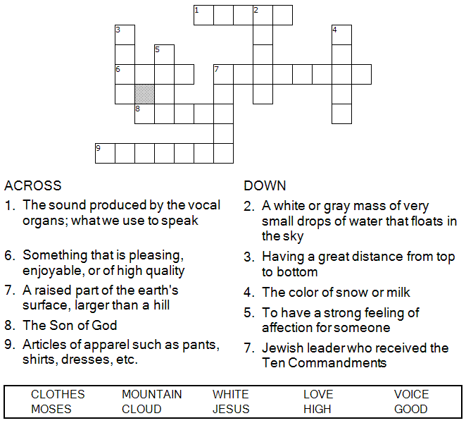


Copyright © Sermons4Kids, Inc.
May be reproduced for Ministry Use
Children’s Worship Bulletin

On the Mountain Top

Mark 9:2-9

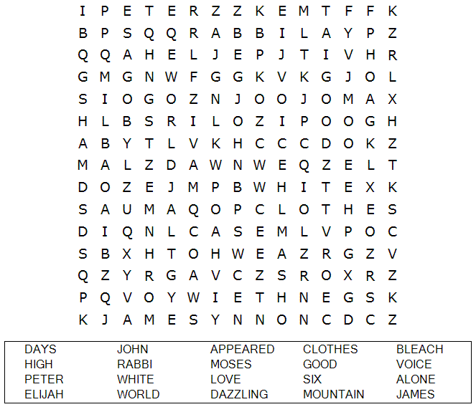
St. Paul’s UCC
301 W. Penn Avenue
Robesonia, PA 19551
610-621-5770

Can you find the way to Jesus, Moses,
and Elijah on the mountain?



And there appeared before them Elijah and Moses,
who were talking with Jesus.
Mark 9:4 (NIV)

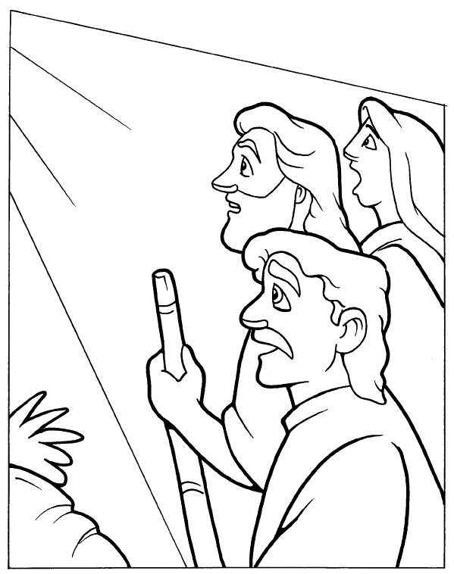
The Transfiguration

