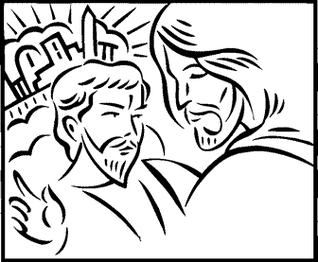

Copyright © Sermons4Kids, Inc.
May be reproduced for Ministry Use

Children’s Worship Bulletin

Jesus in the Wilderness

Mark 1:12-15

St. Paul's UCC
301 W. Penn Avenue
Robesonia, PA 19551
610-621-5770

The words below have been written in code. Use the hints
in the decoder at the top of the puzzle to help break the.
.
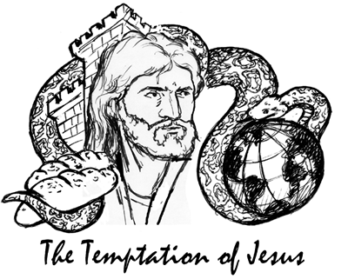

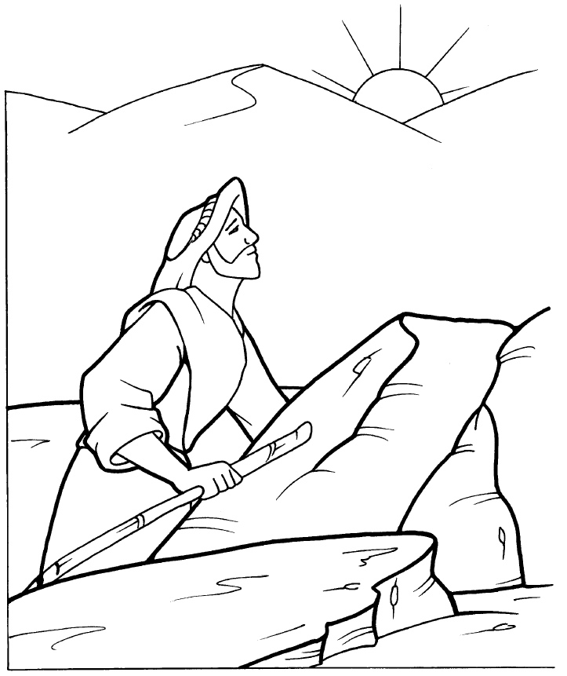
The Temptation of Jesus

Copyright © CalvaryCurriculum.com
Used with Permission

