

Copyright © Sermons4Kids, Inc.
May be reproduced for Ministry Use

Children’s Worship Bulletin

Take Up Your Cross

Mark 8:27-38

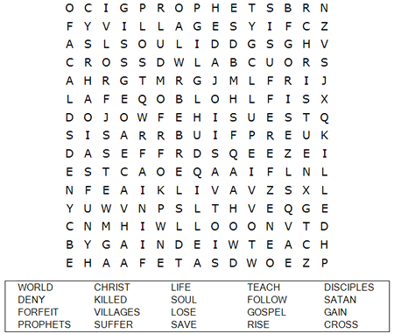

St. Paul’s UCC
301 West Penn Avenue
Robesonia, PA 19551
610-621-5770

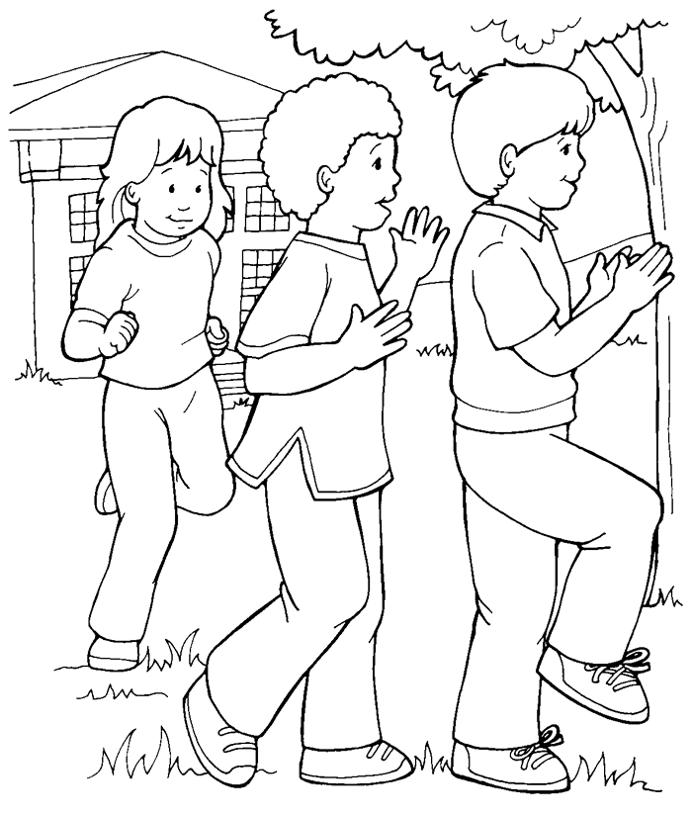

I will follow Jesus, Our Leader

From Thru-the-Bible Coloring Pages for Ages 4-8. © 1988 Standard Publishing.
Used by permission. Reproducible Coloring Books may be purchased
from Standard Publishing, www.standardpub.com, 1-800-323-7543.

Can you find the path to Jesus?

