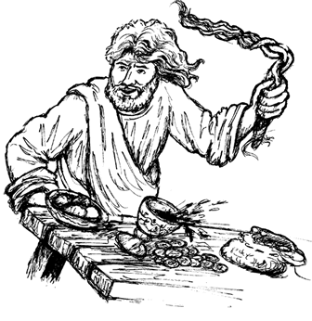
Copyright © Sermons4Kids, Inc.
May be reproduced for Ministry Use
Children’s Worship Bulletin

Cleaning House

John 2:13-16

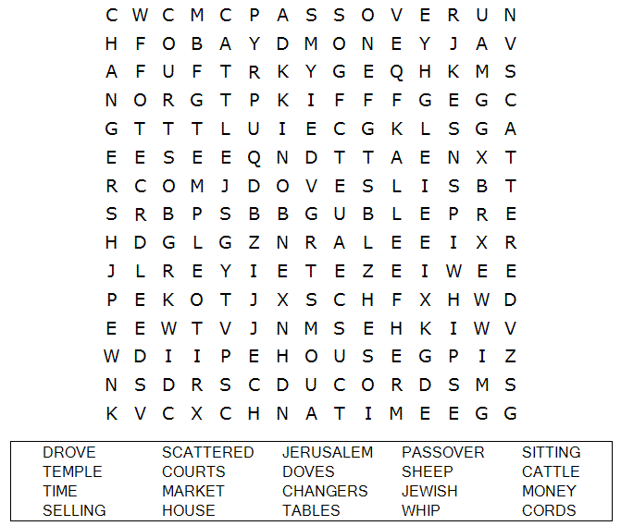
St. Paul’s UCC
301 West Penn Avenue
Robesonia, PA 19551
610-621-5770

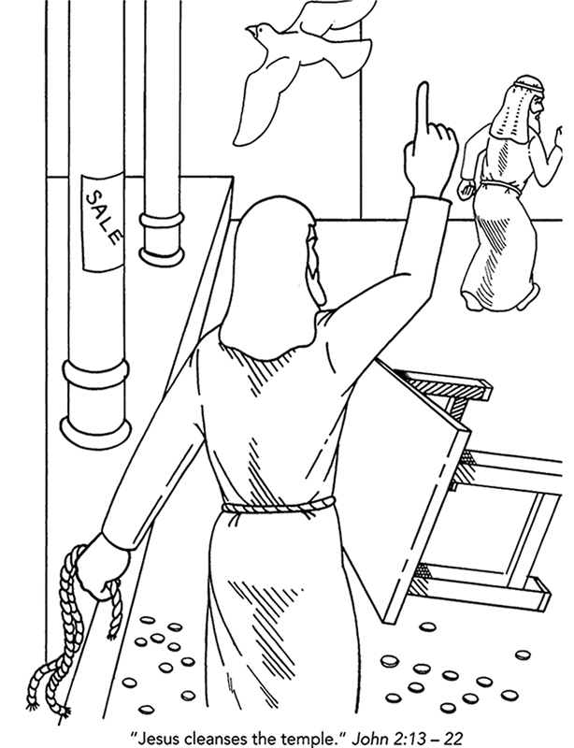

Copyright © CalvaryCurriculum.com
Used by Permission

Choose the word that best matches the definition.
Check your answers in John 2:13-16 (NIV)

