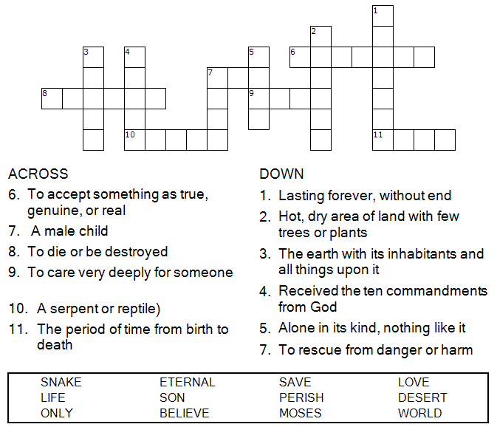

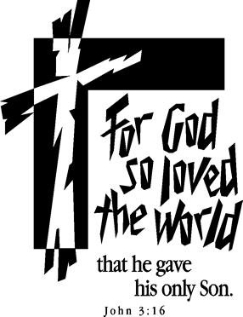

Copyright © Sermons4Kids, Inc.
May be reproduced for Ministry Use
Children’s Worship Bulletin

Measuring God's Love

John 3:14-21

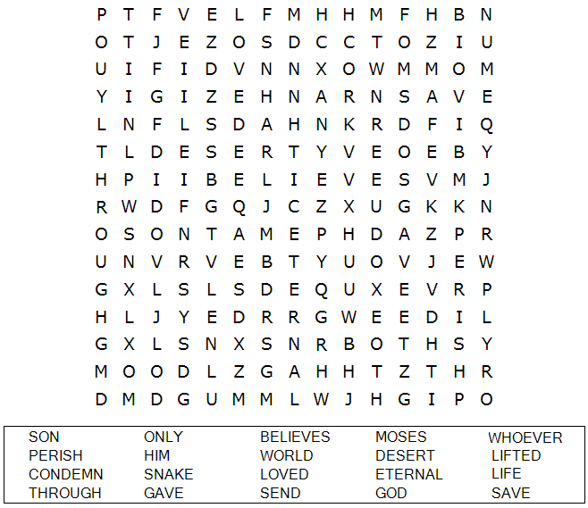
St. Paul’s UCC
301 W. Penn Avenue
Robesonia, PA 19551
610-621-5770

Each number represents a letter of the alphabet.
Substitute the correct letter for the numbers to
reveal the coded words.

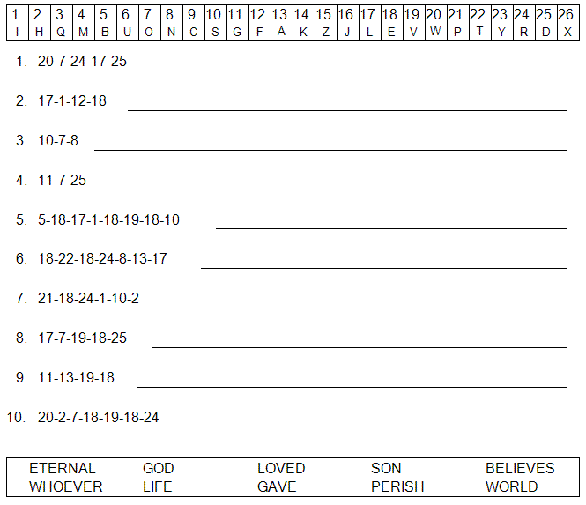



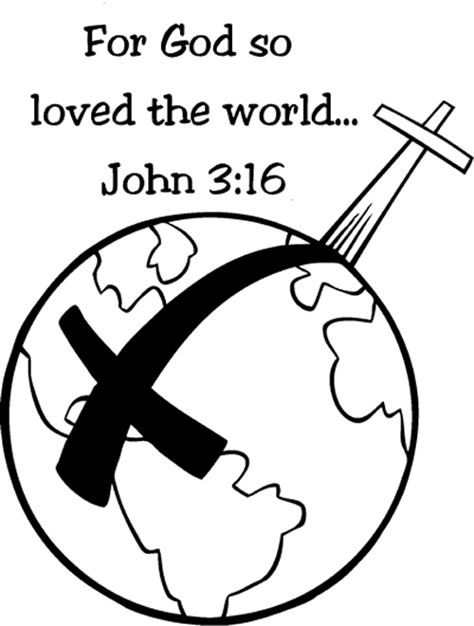

HOW CAN YOU MEASURE GOD’S LOVE?

