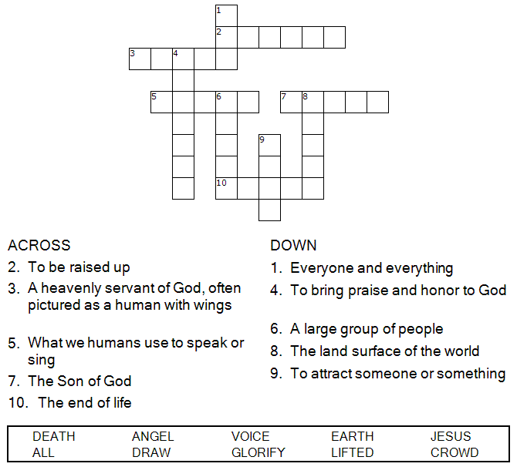


Copyright © Sermons4Kids, Inc.
May be reproduced for Ministry Use

Children’s Worship Bulletin

The Power of His Love

John 12:28-33

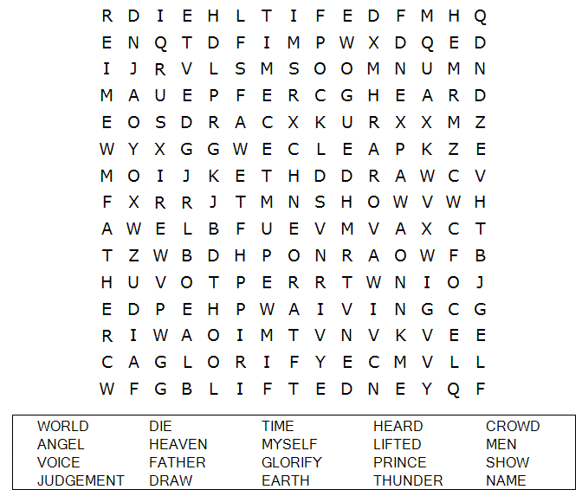

St. Paul’s United Church of Christ
301 West Penn Avenue
Robesonia, PA 19551
610-621-5770

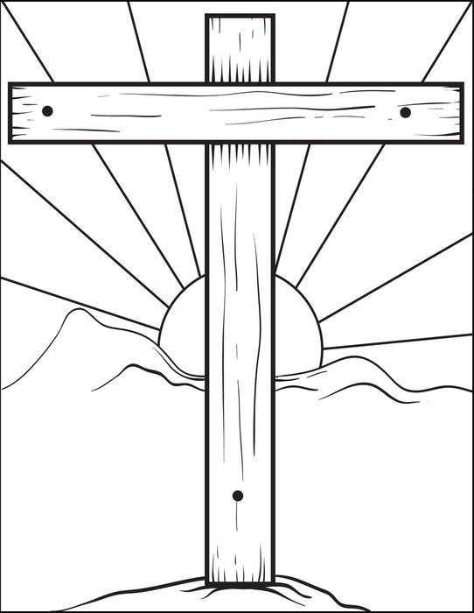

“And I, when I am lifted up from the earth,
will draw all people to myself.”
John 12:32

Choose the word that best matches the definition.
Check your answers in John 12:28-33 (NIV)

