

Copyright © Sermons4Kids, Inc.
May be reproduced for Ministry Use
Children’s Worship Bulletin

The Triumphal Entry

St. Paul’s UCC
301 W. Penn Avenue
Robesonia, PA 19551

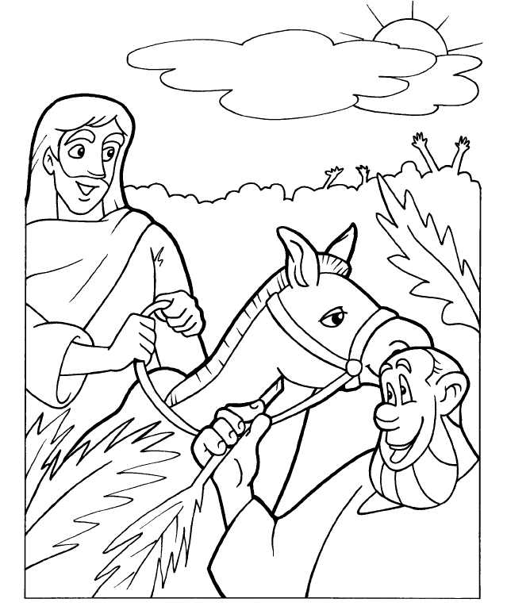
The Triumphal Entry

Copyright CalvaryCurriculum.com
Used by Permission



