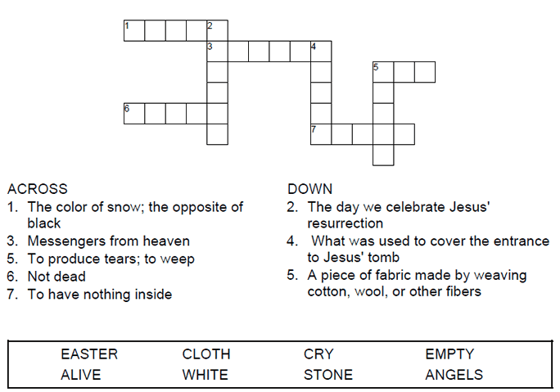

Copyright © Sermons4Kids, Inc.
May be reproduced for Ministry Use


Children’s Worship Bulletin

I’ve Just Seen Jesus

John 20:1-28

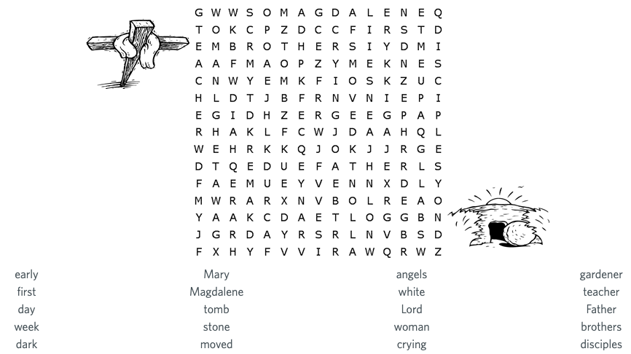

St. Paul’s United Church of Christ
301 West Penn Avenue
Robesonia, PA 19551
610-621-5770

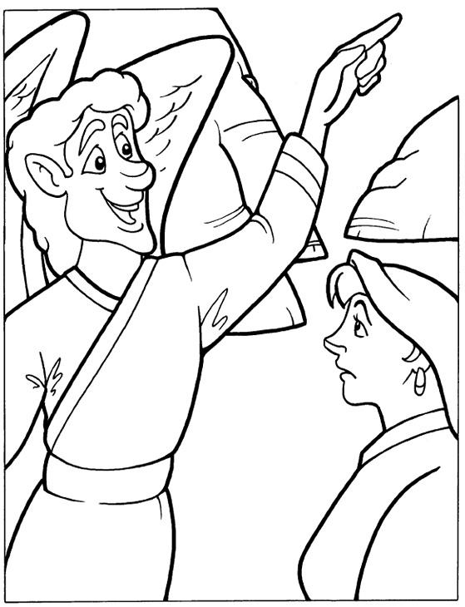

“He is not there, he is risen”
Mark 16:6

Unscramble the letters to discover a secret message.
Check your answers in Mark 16:6 (NIV)

