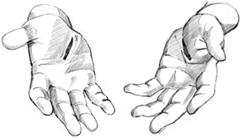

Copyright © Sermons4Kids, Inc.
May be reproduced for Ministry Use
Children’s Worship Bulletin

Seeing Is Believing

John 20:19-31

St. Paul’s United Church of Christ
301 West Penn Avenue
Robesonia, PA 19551
610-621-5770

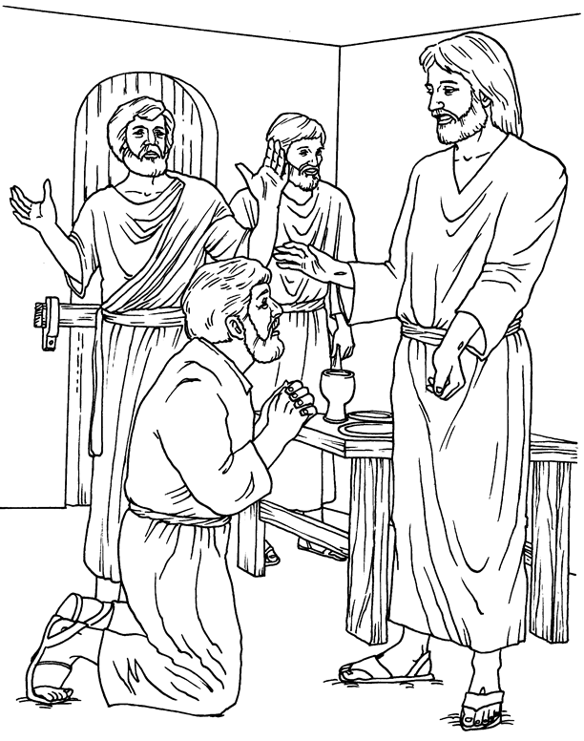
Jesus Appears!

From BibleStoryCard Learning System(tm) Coloring Book © 1996 Wesleyan
Publishing House. Used by permission. Additional BibleStoryCard resources
are available by calling 1-800-493-7539 or visiting online
http://www.wesleyan.org/wph/childrensresources/biblestorycards/biblestorycards.htm

