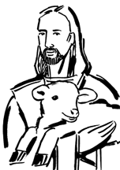

Copyright © Sermons4Kids, Inc.
May be reproduced for Ministry Use
Children’s Worship Bulletin

The Good Shepherd

John 10:11-18

St. Paul’s UCC
301 W. Penn Avenue
Robesonia, PA 19551
610-621-5770

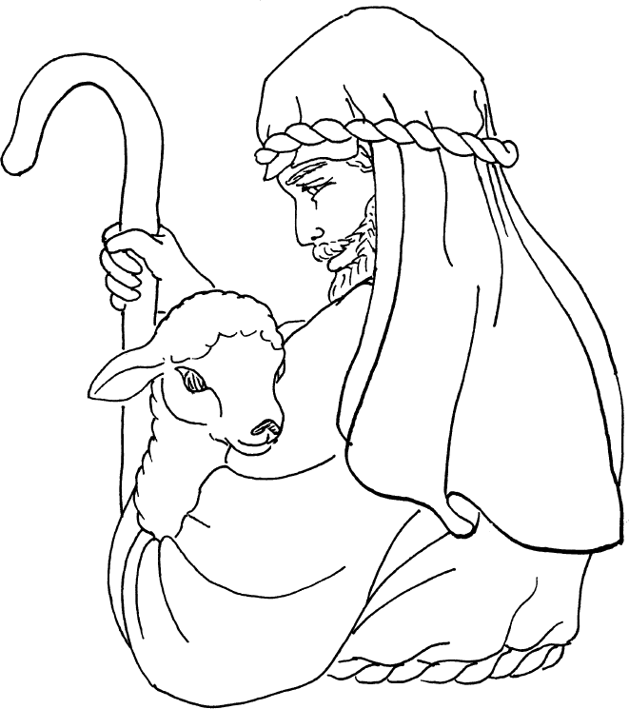

The Good Shepherd

Copyright © CalvaryCurriculum.com
Used by Permission

