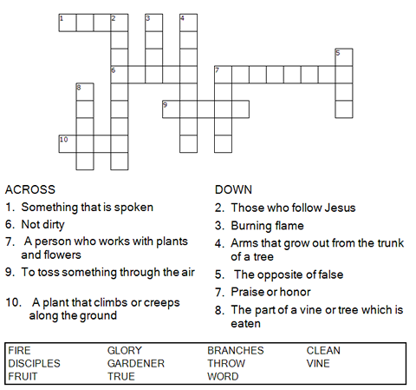

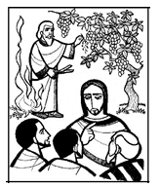

Copyright © Sermons4Kids, Inc.
May be reproduced for Ministry Use

Children’s Worship Bulletin

The True Vine

John 15:1-8

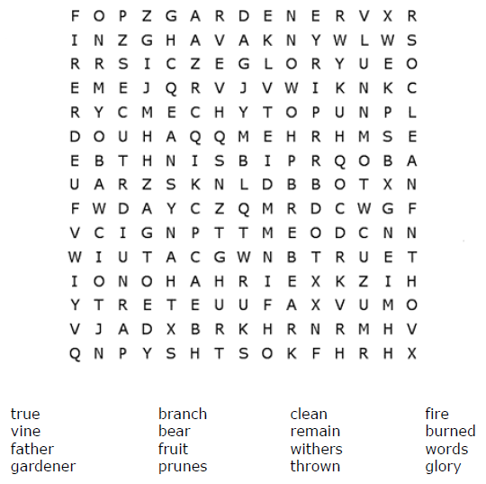
St. Paul’s UCC
301 W. Penn Avenue
Robesonia, PA 19551
610-621-5770

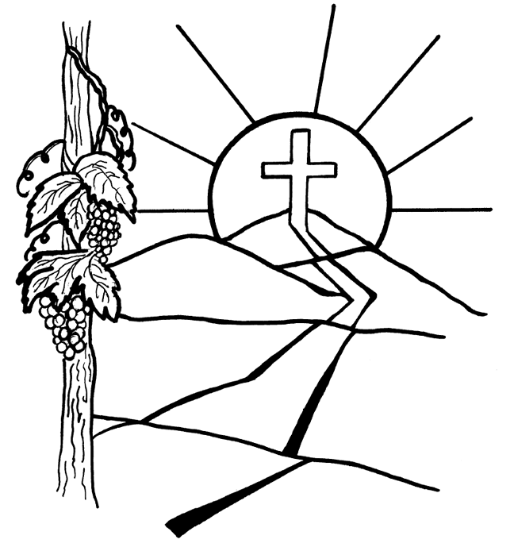

""I am the vine; you are the branches. If a man remains in me and I in him, he will bear much fruit; apart from me you can do nothing. This is to my Father's glory, that you bear much fruit, showing yourselves to be my disciples."

John 15:5, 8 (NIV)

Unscramble the four words and use the letters in the numbered boxes to solve the puzzle.

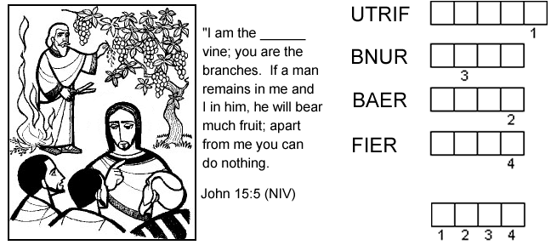

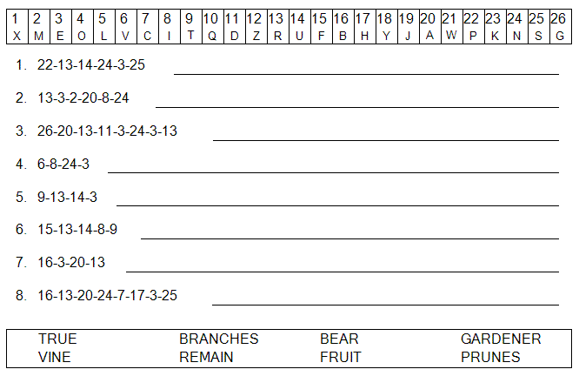
WORD JUMBLE ANSWERS
Words: FRUIT, BURN, BEAR, FIRE
Puzzle Solution: TRUE

