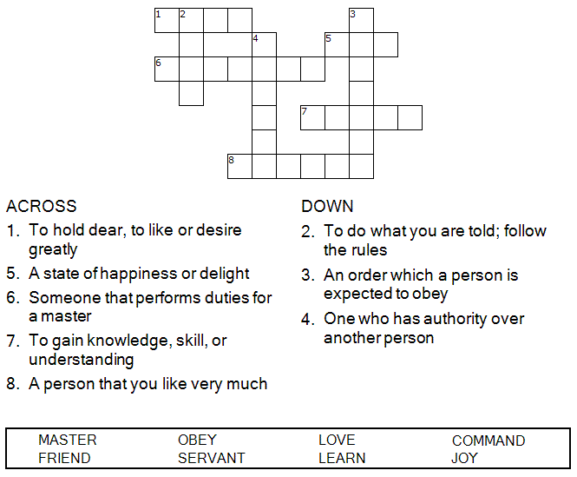



Copyright © Sermons4Kids, Inc.
May be reproduced for Ministry Use
Children’s Worship Bulletin

Love One Another

John 15:9-17

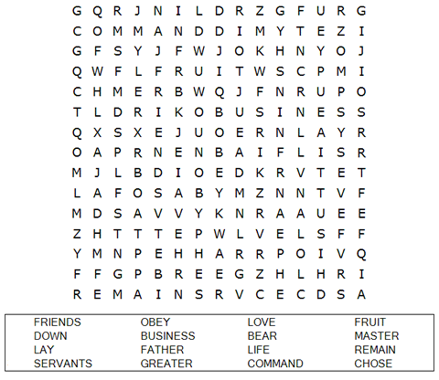

St. Paul’s UCC
301 W. Penn Avenue
Robesonia, PA 19551
610-621-5770



"My command is this: Love each other as I have loved you. Greater love has no one than this, that he lay down his life for his friends. You are my friends if you do what I command."

John 15:12-14 (NIV)

Each number represents a letter of the alphabet. Substitute
the correct letter for the numbers to reveal the coded words.



