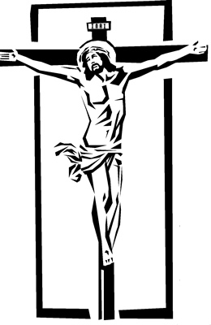
Copyright © Sermons4Kids, Inc.
May be reproduced for Ministry Use

Children’s Worship Bulletin

The Greatest Gift of All

John 3:14-17

St. Paul’s UCC
301 W. Penn Avenue
Robesonia, PA 19551
610-621-5770





For God so loved the world that he gave his one and
only Son, that whoever believes in him shall not
perish but have eternal life.
John 3:16 (NIV)



