

Copyright © Sermons4Kids, Inc.
May be reproduced for Ministry Use
Children’s Worship Bulletin

Who Me? Not Me!

Genesis 3:8-15

St. Paul’s UCC
301 W. Penn Avenue
Robesonia, PA 19551
610-621-5770

Adam and Eve are Tempted
Genesis 3:8-15
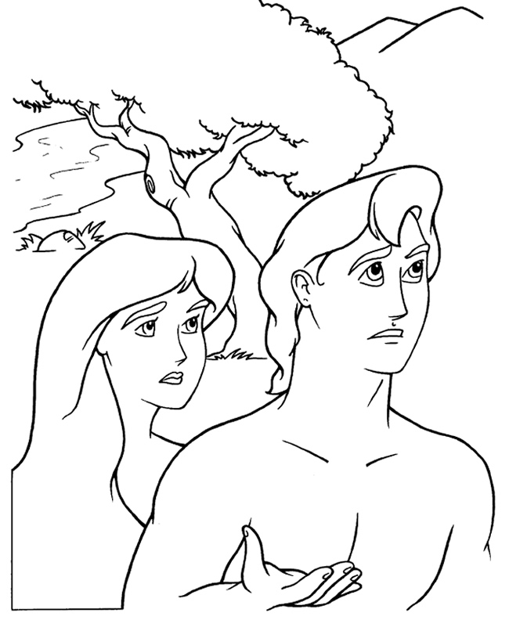

Copyright © CalvaryCurriculum.com
Used by Permission

Each number represents a letter of the alphabet.
Substitute the correct letter for the numbers.

