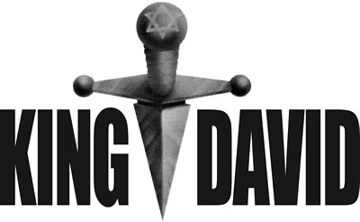

Copyright © Sermons4Kids, Inc.
May be reproduced for Ministry Use
Children’s Worship Bulletin

David is Anointed King

1 Samuel 16:1-13

St. Paul’s UCC
301 W. Penn Avenue
Robesonia, PA 19551
610-621-5770

From the words provided for each clue, write the
letter of the word which best matches the clue.
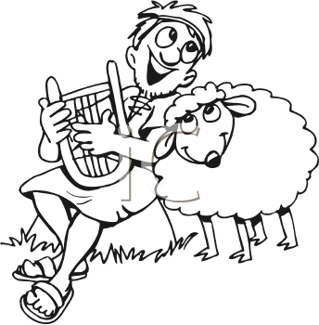

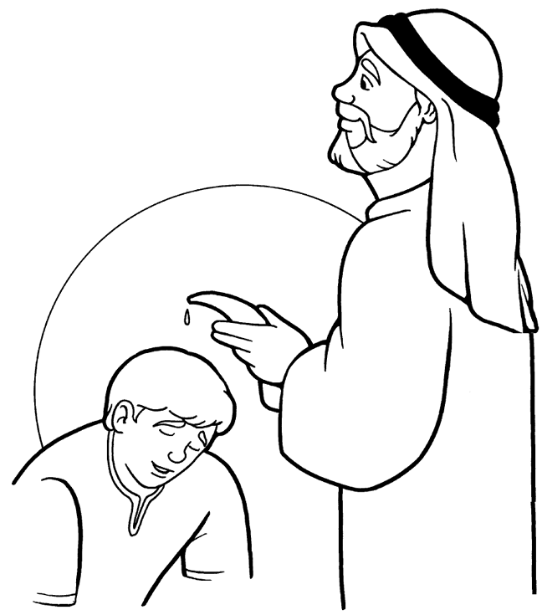

The LORD does not look at the things man looks at.
Man looks at the outward appearance,
but the LORD looks at the heart."
1 Samuel 16:7 (NIV)

