Jesus Calms a Storm

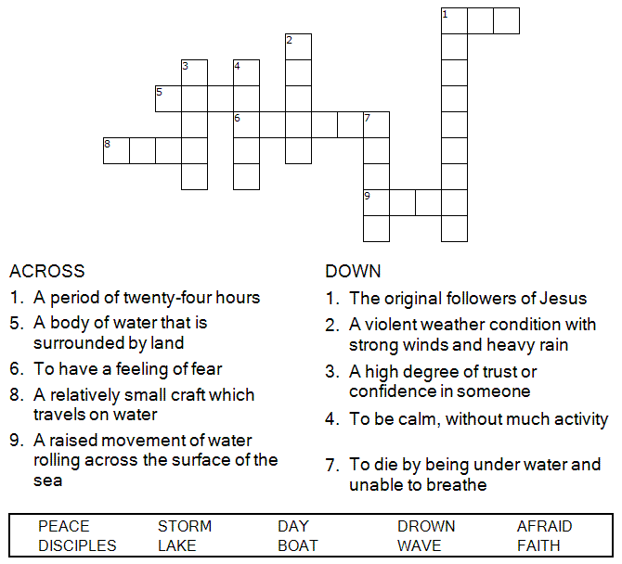



Copyright © Sermons4Kids, Inc.
May be reproduced for Ministry Use

Children’s Worship Bulletin

Who's in Your Boat?

Mark 4:35-41

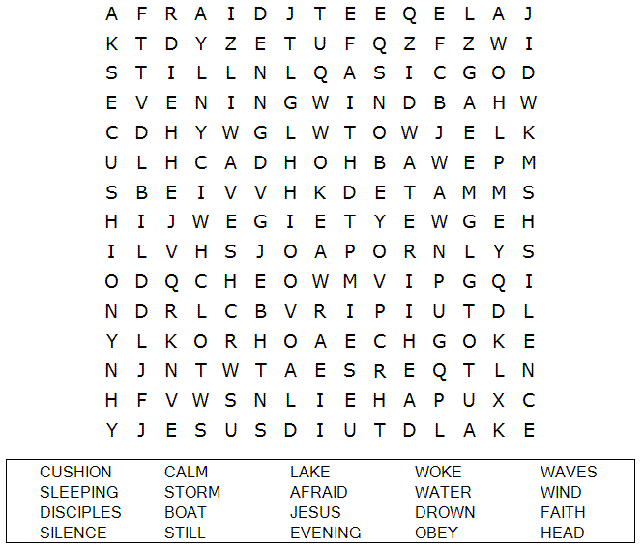

St. Paul’s UCC
301 W. Penn Avenue
Robesonia, PA 19551
610-621-5770

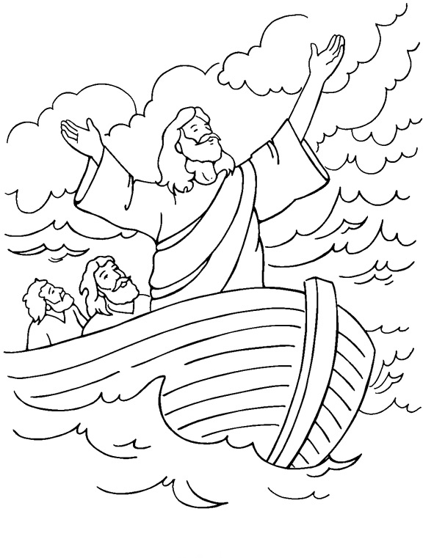
Jesus Calms the Storm
From Thru-the-Bible Coloring Pages for Ages 4-8. © Standard Publishing.
Used by permission. Reproducible Coloring Books may be purchased from
Standard Publishing, www.standardpub.com, 1-800-543-1301.

Unscramble each word and then place the numbered letters
in the numbered boxes at the bottom to reveal the answer.

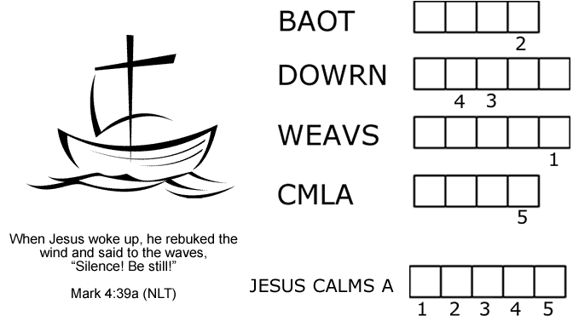

PUZZLE CLUES

1. Jesus and his disciples got in a ________.
2. The disciples were afraid that they were going to _________.
3. Jesus spoke to the wind and the __________.
4. After Jesus spoke, the sea became __________.
Answer: There was a fierce ___________ on the sea.
Check your answers in Mark 4:35-41 (NIV)
The disciples were absolutely terrified. “Who is this man?” they asked each other. “Even the
wind and waves obey him!”
Mark 4:41 (NLT)

