Jesus Heals a Woman

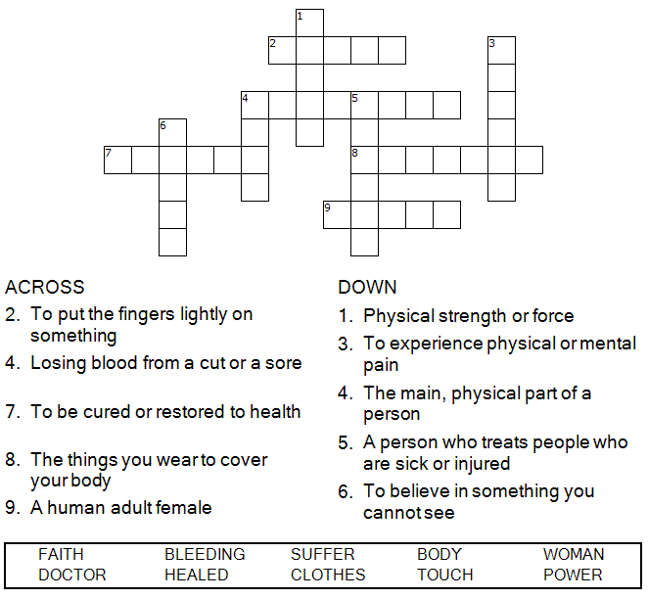



Copyright © Sermons4Kids, Inc.
May be reproduced for Ministry Use

Children’s Worship Bulletin

There Is Power in a Touch

Mark 5:25-34

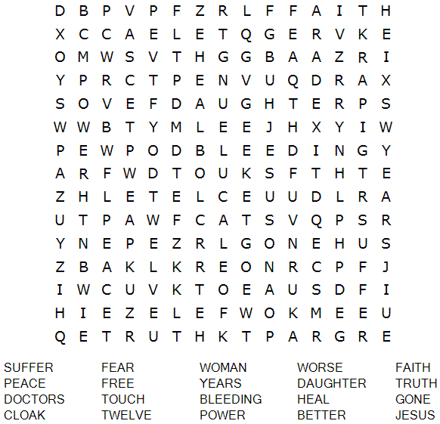

St. Paul’s UCC
301 W. Penn Avenue
Robesonia, PA 19551
610-621-5770

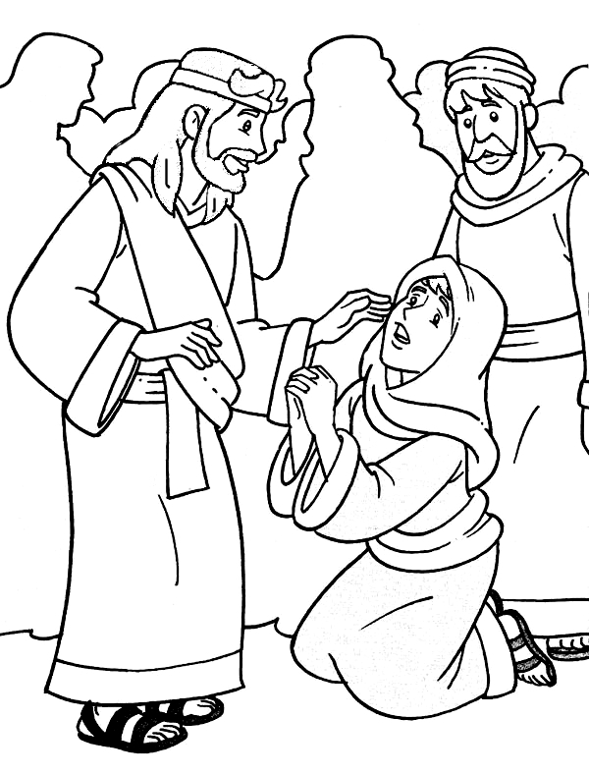
“If I just touch his clothes, I will be healed.”
Mark 5:28

Unscramble each word and then place the numbered letters
in the numbered boxes at the bottom to reveal the answer.

