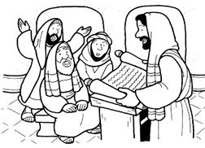

Copyright © Sermons4Kids, Inc.
May be reproduced for Ministry Use
Children’s Worship Bulletin

Jesus Is Rejected in Nazareth

Mark 6:1-6

St. Paul’s UCC
301 W. Penn Avenue
Robesonia, PA 19551
610-621-5770

Jesus said to them, "Only in his hometown, among his relatives
and in his own house is a prophet without honor."
Mark 6:4 (NIV)
Copyright © CalvaryCurriculum.com
Used by permission.

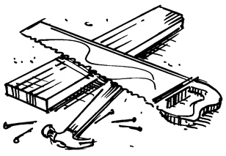
Isn’t this the carpenter?

