He Has Chosen Us

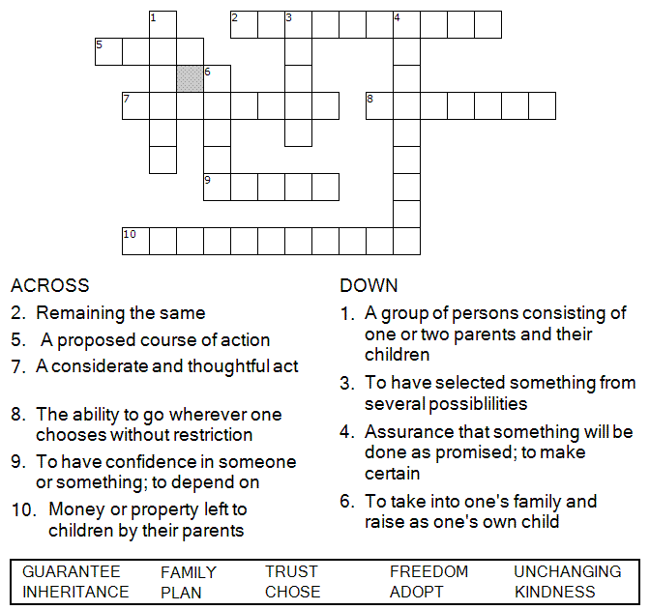



Copyright © Sermons4Kids, Inc.
May be reproduced for Ministry Use

Children’s Worship Bulletin

He Has Chosen Us!

Ephesians 1:3-14

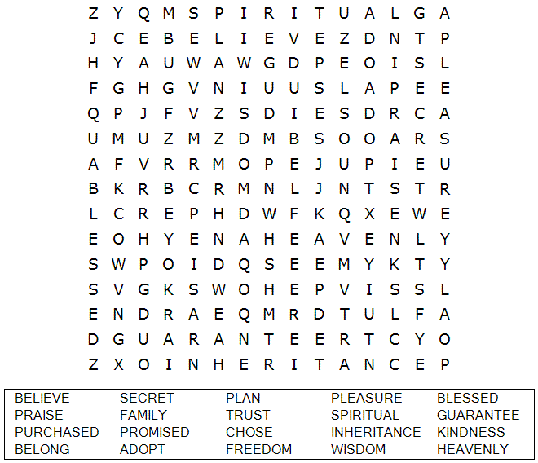
St. Paul’s UCC
301 W. Penn Avenue
Robesonia, PA 19551
610-621-5770

Jesus and the Children

From Thru-the-Bible Coloring Pages © 1986,1988 Standard Publishing.
Used by permission. Reproducible Coloring Books may be purchased from
Standard Publishing, www.standardpub.com, 1-800-323-7543.

Each number represents a letter of the alphabet. Substitute the correct letter for the numbers to reveal the coded words.

