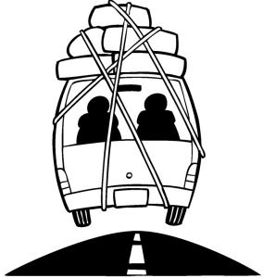

Copyright © Sermons4Kids, Inc.
May be reproduced for Ministry Use
Children’s Worship Bulletin

Getting Away from It All

Mark 6:30-34

St. Paul’s UCC
301 W. Penn Avenue
Robesonia, PA 19551
610-621-5770

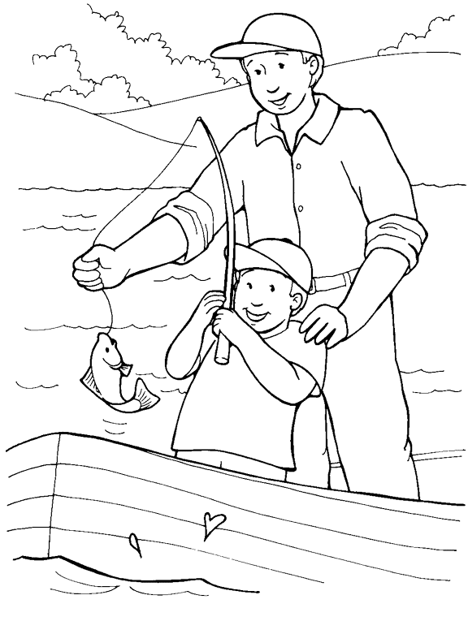
"Come with me by yourselves to a quiet place
and get some rest."
Mark 6:31
From Thru-the-Bible Coloring Pages © 1986,1988 Standard Publishing.
Used by permission. Reproducible Coloring Books may be purchased
from Standard Publishing, www.standardpub.com, 1-800-323-7543.



