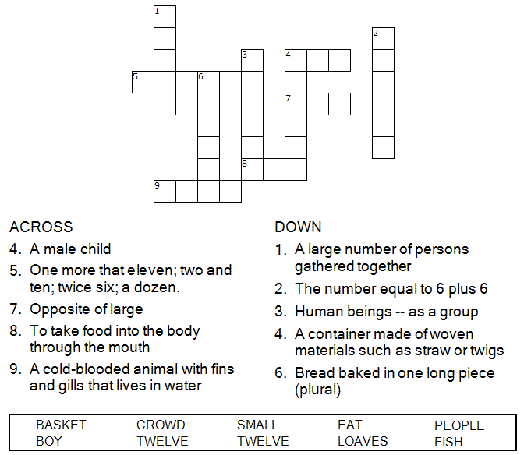



Copyright © Sermons4Kids, Inc.
May be reproduced for Ministry Use

Children’s Worship Bulletin

Jesus Feeds 5,000

John 6:1-15

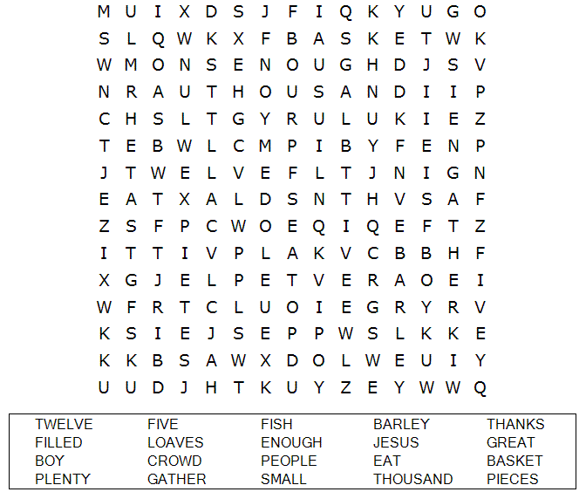

St. Paul’s UCC
301 West Penn Avenue
Robesonia, PA 19551
610-621-5770

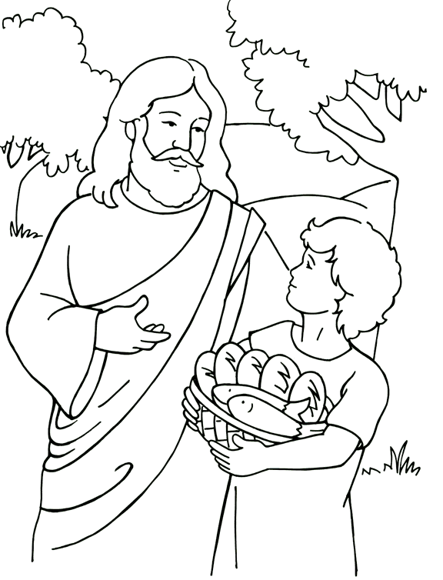
Jesus Feeds 5,000
From Thru-the-Bible Coloring Pages for Ages 4-8. © Standard Publishing.
Used by permission. Reproducible Coloring Books may be purchased
from Standard Publishing, www.standardpub.com.

Each number represents a letter of the alphabet. Substitute
the correct letter for the numbers to reveal the coded words.

