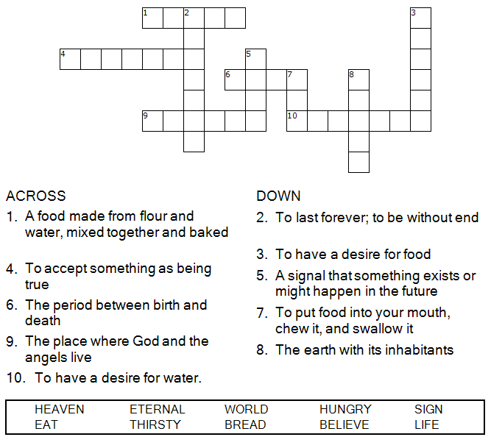



Copyright © Sermons4Kids, Inc.
May be reproduced for Ministry Use

Children’s Worship Bulletin

Looking for a Sign

John 6:24-35

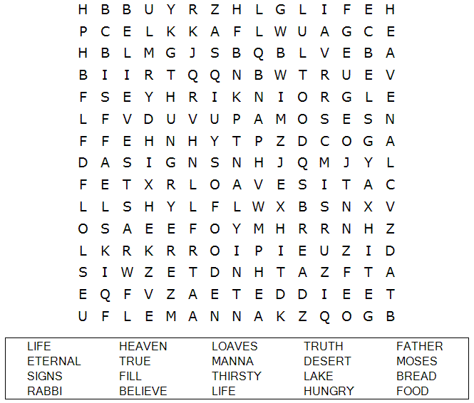

St. Paul’s UCC
301 W. Penn Avenue
Robesonia, PA 19551
610-621-5770

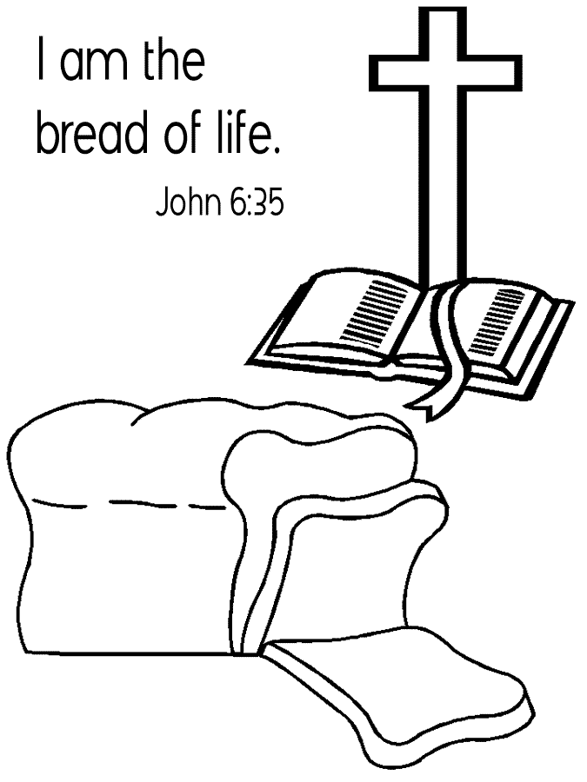

Choose the word that best matches the definition.
Put the letter for that word in the blank next
to the definition.

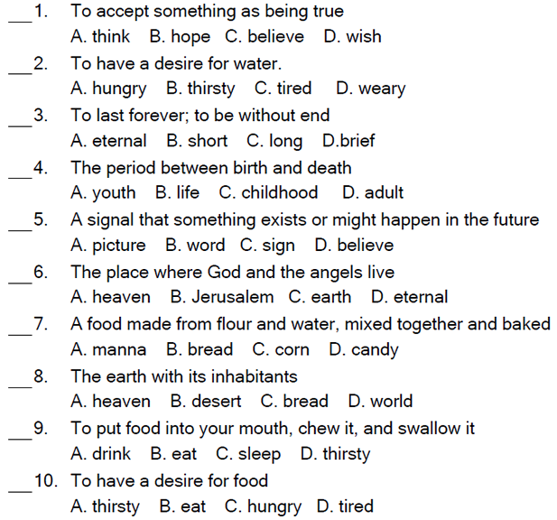


When they had all had enough to eat, he said to his disciples, "Gather the pieces that are left over. Let nothing be wasted." So they gathered them and filled twelve baskets with the pieces of the five barley loaves left over by those who had eaten.
John 6:12-13 (NIV)

