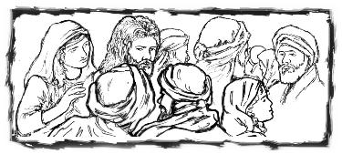

Copyright © Sermons4Kids, Inc.
May be reproduced for Ministry Use

Children’s Worship Bulletin

Clean or Unclean?

Mark 7:1-8; 14-15; 21-23

St. Paul’s UCC
301 West Penn Avenue
Robesonia, PA 19551
610-621-5770

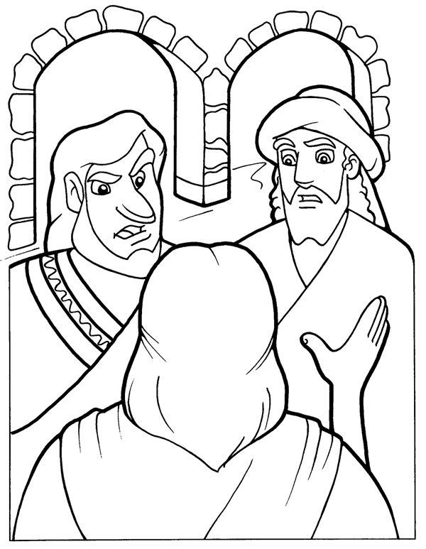
"These people honor me with their lips,
but their hearts are far from me."
Mark 7:6

Copyright © CalvaryCurriculum.com
Used by Permission

Each number represents a letter of the alphabet. Substitute the correct letter for the numbers to reveal the words.

