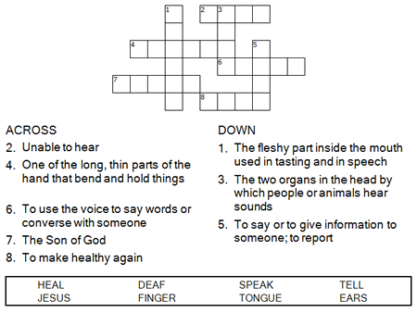



Copyright © Sermons4Kids, Inc.
May be reproduced for Ministry Use

Children’s Worship Bulletin

He does all things well!

Mark 7:31-37

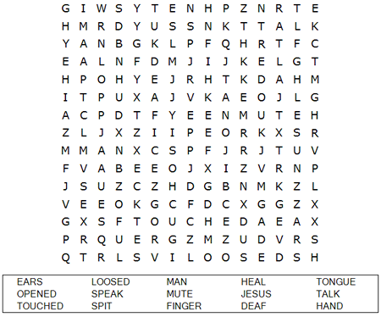
St. Paul’s UCC
301 West Penn Avenue
Robesonia, PA 19551
610-621-5770

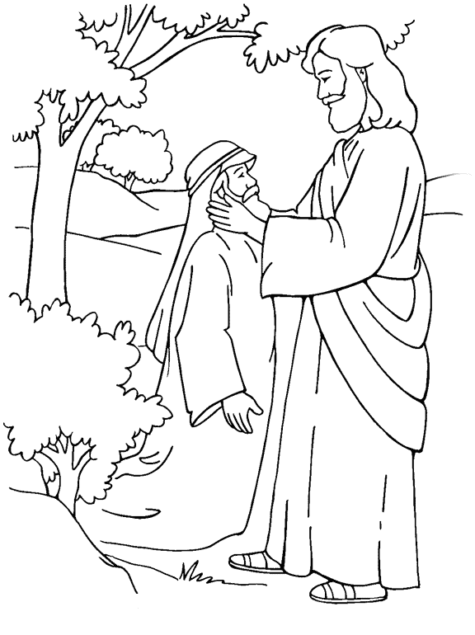
Jesus Heals a Deaf Man
Mark 7:31-37

From Thru-the-Bible Coloring Pages for Ages 4-8. © Standard Publishing.
Used by permission. Reproducible Coloring Books may be purchased from
Standard Publishing, www.standardpub.com, 1-800-543-1301.

Each number represents a letter of the alphabet. Substitute the correct letter for the numbers to reveal the words.

