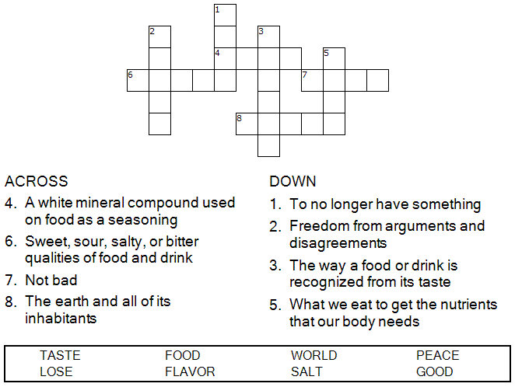



Copyright © Sermons4Kids, Inc.
May be reproduced for Ministry Use

Children’s Worship Bulletin

Pass the Salt, Please

Mark 9:38-50

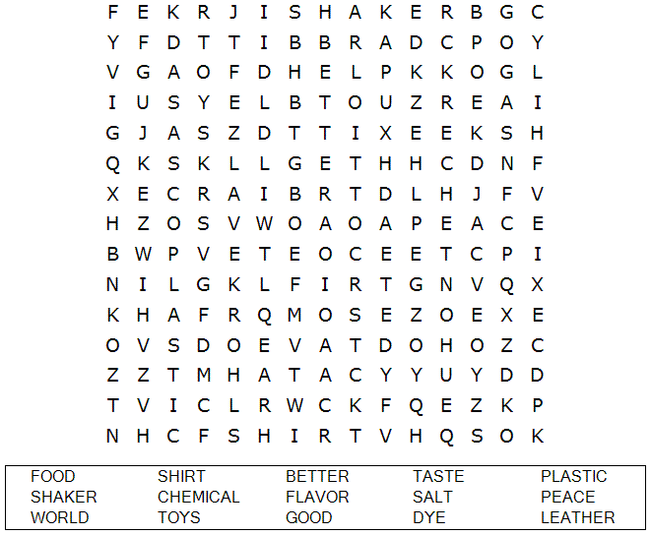

St. Paul’s UCC
301 W. Penn Avenue
Robesonia, PA 19551
610-621-5770



“Salt is good, but if it loses its saltiness, how can you
make it salty again? Have salt among yourselves,
and be at peace with each other.”
Mark 9:50 (NIV)

Each number represents a letter of the alphabet. Substitute the correct letter for the numbers
to reveal the coded words.

