

Copyright © Sermons4Kids, Inc.
May be reproduced for Ministry Use
Children’s Worship Bulletin

God of the Impossible

Mark 10:17-31

St. Paul’s UCC
301 W. Penn Avenue
Robesonia, PA 19551
610-621-5770

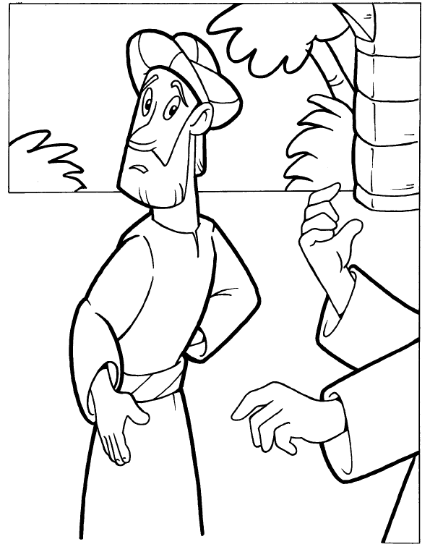
The Rich Young Ruler

Copyright © CalvaryCurriculum.com
Used by Permission



