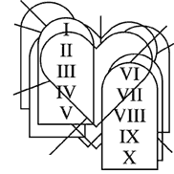

Copyright © Sermons4Kids, Inc.
May be reproduced for Ministry Use

Children’s Worship Bulletin

The Greatest Commandment

Mark 12:28-34

St. Paul's UCC
301 W. Penn Avenue
Robesonia, PA 19551
610-621-5770

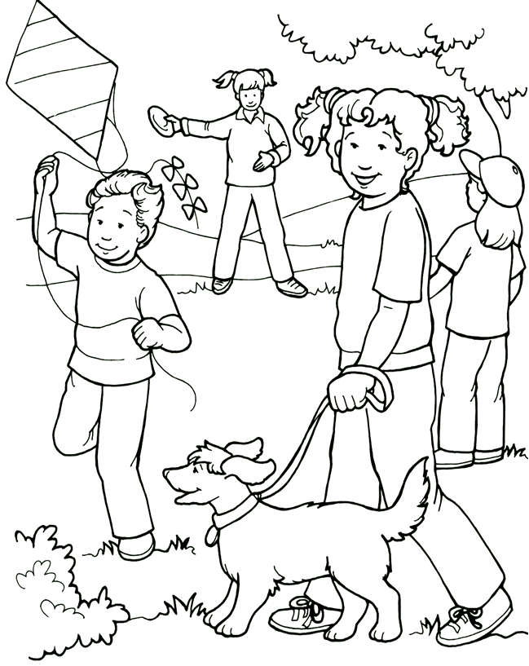
Love Your Neighbor as Yourself

From Thru-the-Bible Coloring Pages for Ages 4-8. © 1988 Standard Publishing.
Used by permission. Reproducible Coloring Books may be purchased from
Standard Publishing, www.standardpub.com, 1-800-543-1301.

Beginning with the letter a, connect the dots in alphabetical
order to complete the picture.

