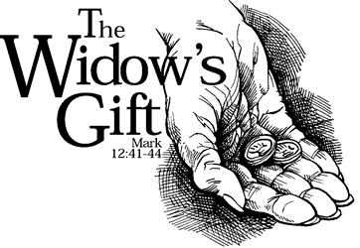

Copyright © Sermons4Kids, Inc.
May be reproduced for Ministry Use

Children’s Worship Bulletin

The Widow's Mite

Mark 12:38-44

St. Paul’s UCC
301 W. Penn Avenue
Robesonia, PA 19551
610-621-5770

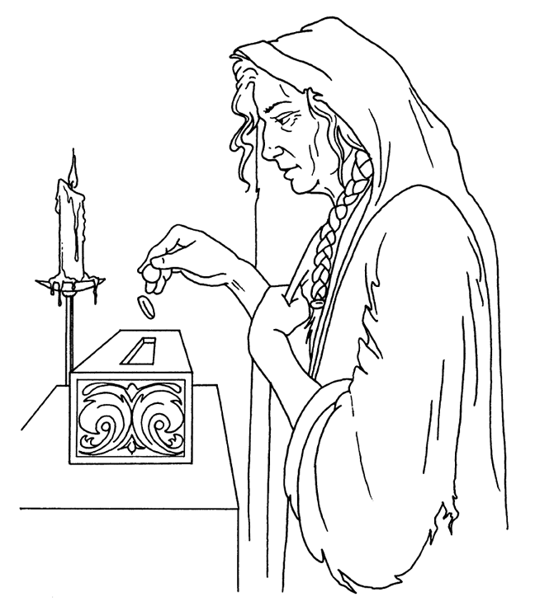

The Widow’s Mite

Copyright © CalvaryCurriculum.com
Used by Permission

Each number represents a letter of the alphabet. Substitute the
correct letter for the numbers to reveal the coded words.



