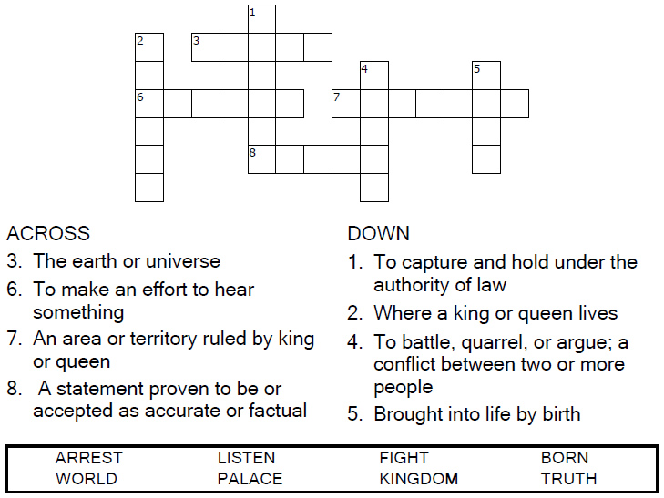

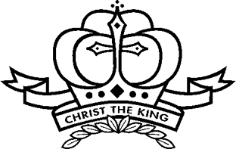

Copyright © Sermons4Kids, Inc.
May be reproduced for Ministry Use

Children’s Worship Bulletin

Christ the King

John 18:33-37

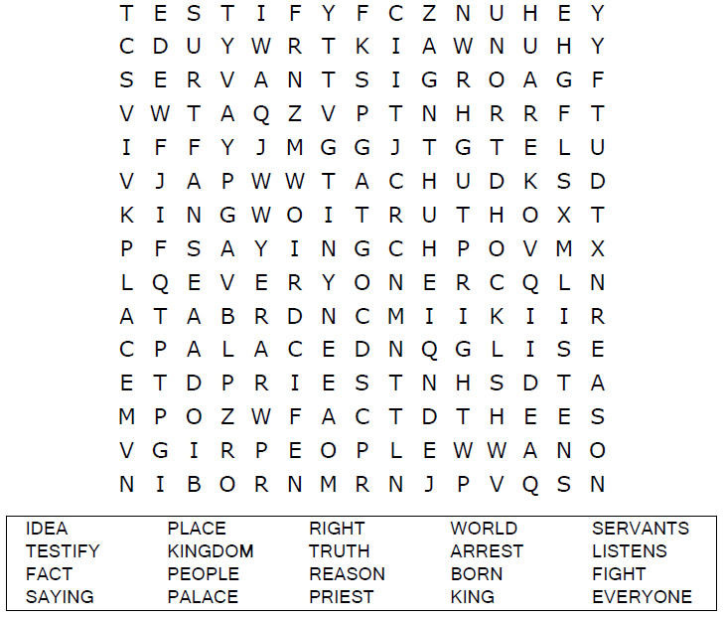
St. Paul’s UCC
301 W. Penn Avenue
Robesonia, PA 19551
610-621-5770

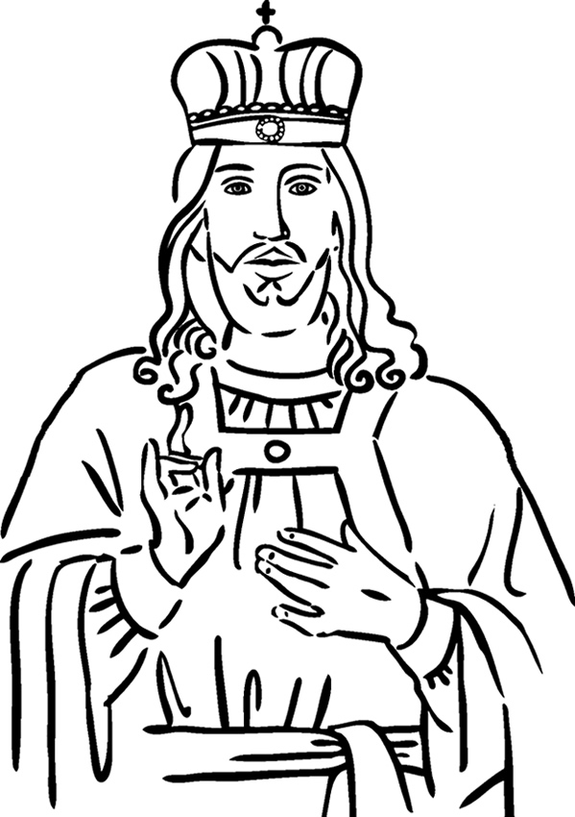

Christ the King
John 18:33-37

Each number represents a letter of the alphabet. Substitute the
correct letter for the numbers to reveal the coded words.

