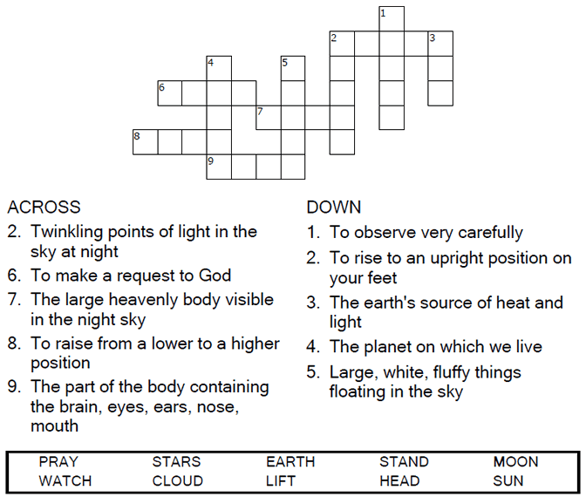



Copyright © Sermons4Kids, Inc.
May be reproduced for Ministry Use

Children’s Worship Bulletin

Are You Ready?

Luke 21:25-36

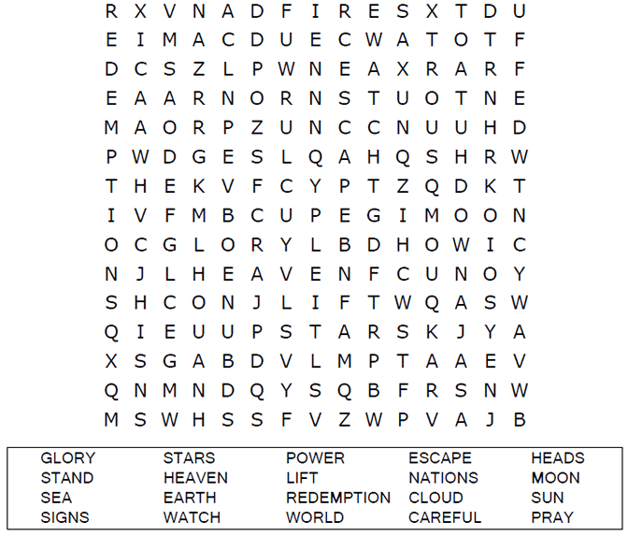

St. Paul’s UCC
301 W. Penn Avenue
Robesonia, PA 19551
610-621-5770

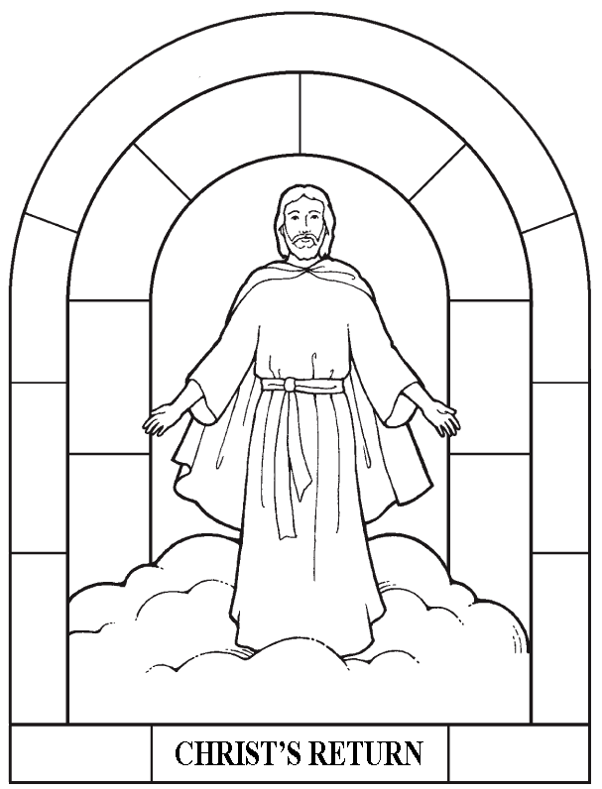

"Then everyone will see the Son of Man coming
on a cloud with power and great glory.”
Luke 21:27

Each number represents a letter of the alphabet. Substitute the
correct letter for the numbers to reveal the coded words.

