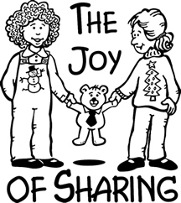

Copyright © Sermons4Kids, Inc.
May be reproduced for Ministry Use
Children’s Worship Bulletin

The Joy of Christmas

Luke 3:7-11

St. Paul’s UCC
301 W. Penn Avenue
Robesonia, PA 19551
610-621-5770



The Candle of Joy

Each number represents a letter of the alphabet. Substitute the
correct letter for the numbers to reveal the coded words.

