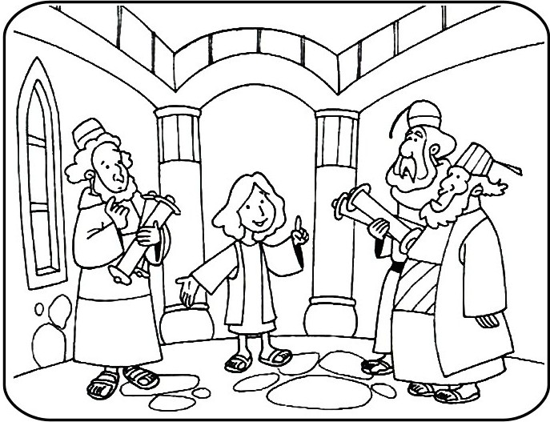
Copyright © Sermons4Kids, Inc.
May be reproduced for Ministry Use
Children’s Worship Bulletin

Boy Jesus in the Temple

Luke 2:41-52

St. Paul’s UCC
301 W. Penn Avenue
Robesonia, PA 19551
610-621-5770

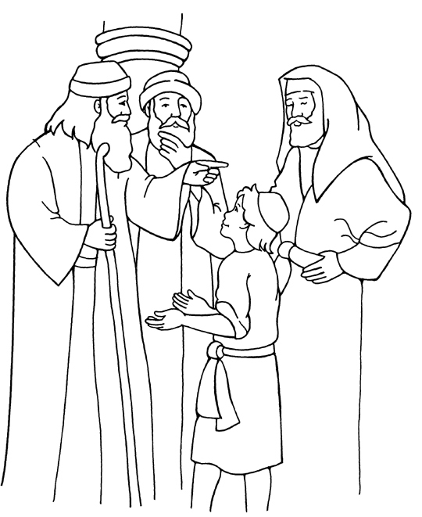
Jesus in the Temple
Luke 2

From Thru-the-Bible Coloring Pages for Ages 4-8. © 1986,1988 Standard
Publishing. Used by permission. Reproducible Coloring Books may be
purchased from Standard Publishing, www.standardpub.com.

Can you help Mary and Joseph find Jesus in the Temple?

