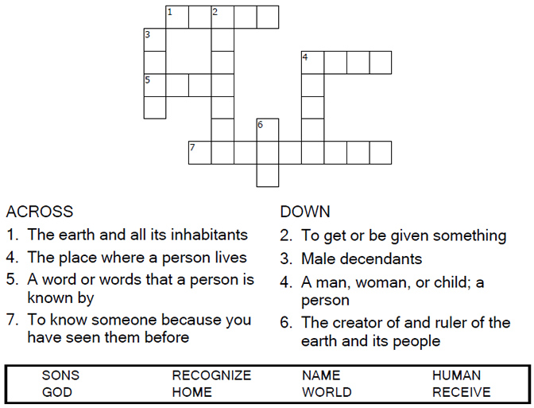

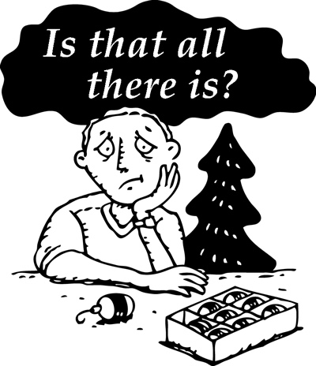
Copyright © Sermons4Kids, Inc.
May be reproduced for Ministry Use

Children’s Worship Bulletin

Is Christmas Really Over?

John 1:10-18

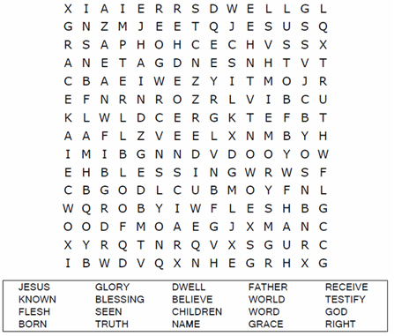
St. Paul’s UCC
301 W. Penn Avenue
Robesonia, PA 19551
610-621-5770

Each number represents a letter of the alphabet. Substitute the correct letter for the numbers to reveal the coded words.

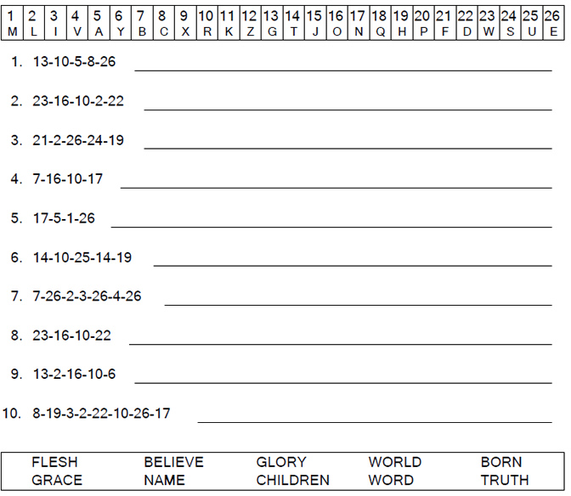

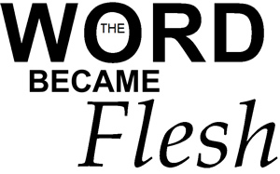

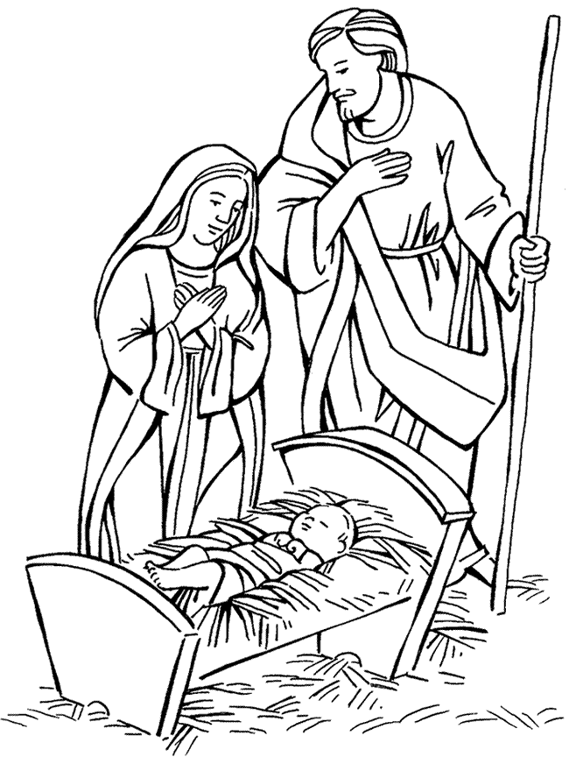

The Word became flesh and made his dwelling among us.
John 1:14

