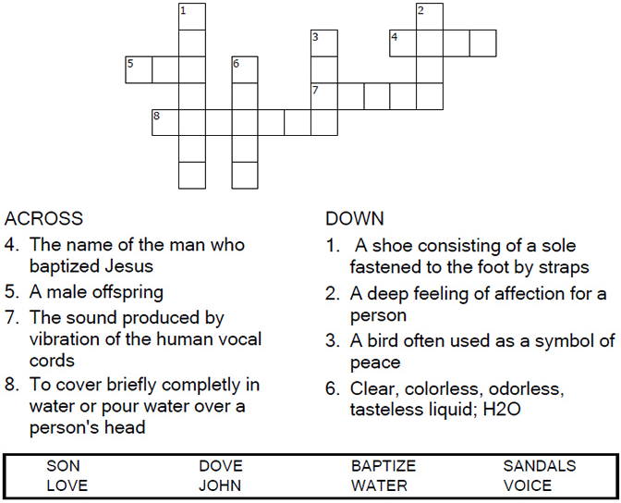

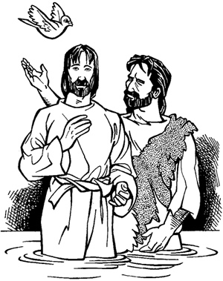
Copyright © Sermons4Kids, Inc.
May be reproduced for Ministry Use
Children’s Worship Bulletin

Jesus, the One and Only

Luke 3:15-17, 21-22

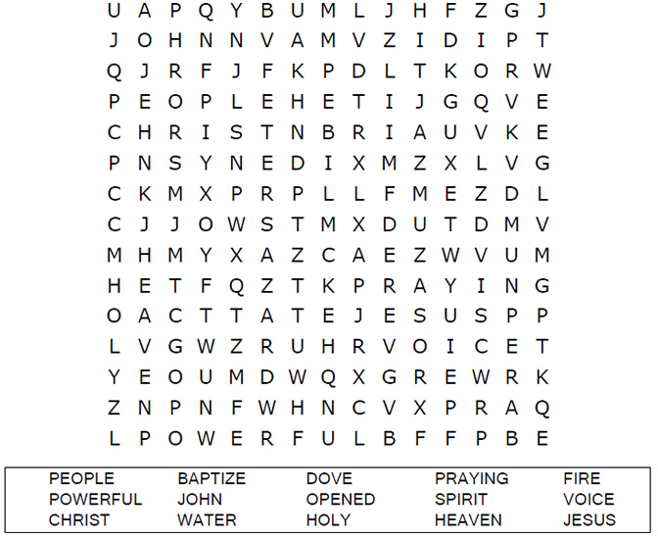
St. Paul’s UCC
301 W. Penn Avenue
Robesonia, PA 19551
610-621-5770

Each number represents a letter of the alphabet. Substitute the correct letter for the numbers to reveal the coded words.

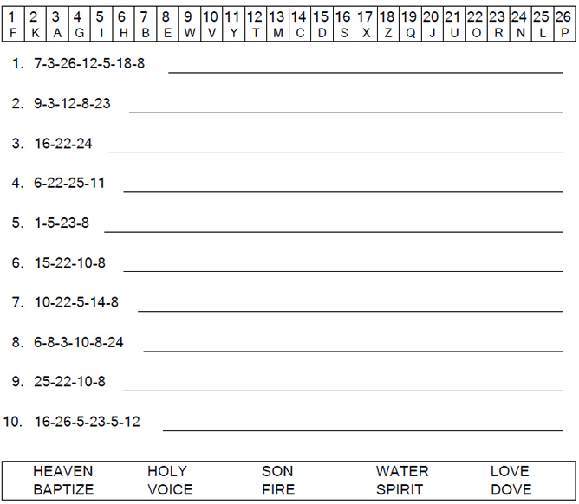

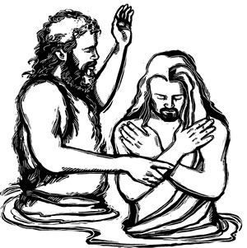

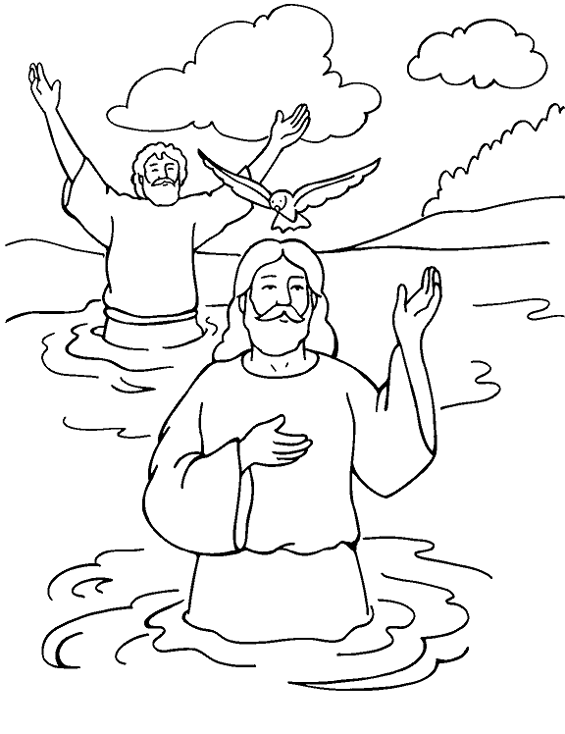
John Baptizes Jesus
Matthew 3, Mark 1, Luke 3

From Thru-the-Bible Coloring Pages for Ages 4-8. © Standard Publishing.
Used by permission. Reproducible Coloring Books may be purchased from
Standard Publishing, www.standardpub.com, 1-800-543-1301.

