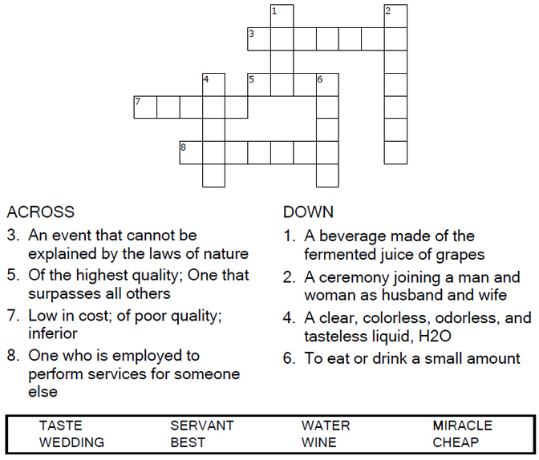

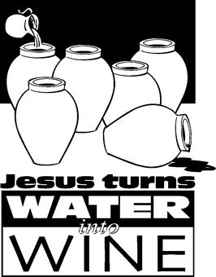
Copyright © Sermons4Kids, Inc.
May be reproduced for Ministry Use
Children’s Worship Bulletin

Jesus Turns Water Into Wine

John 2:1-11

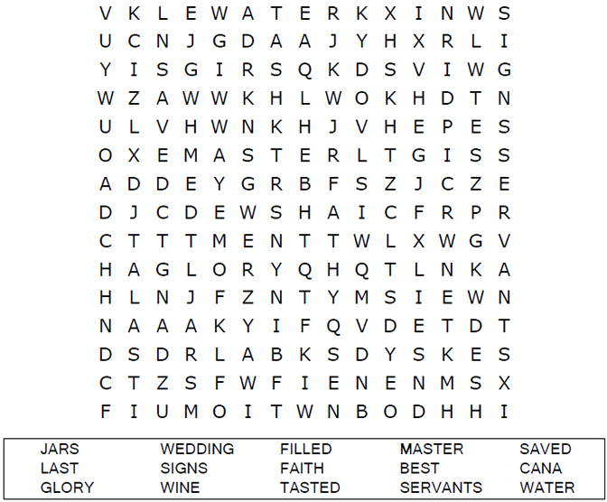
St. Paul’s UCC
301 W. Penn Avenue
Robesonia, PA 19551
610-621-5770

Choose the word that best matches the definition.

The Miracles of Jesus
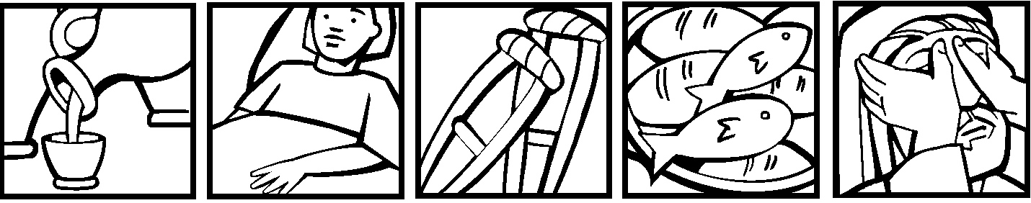

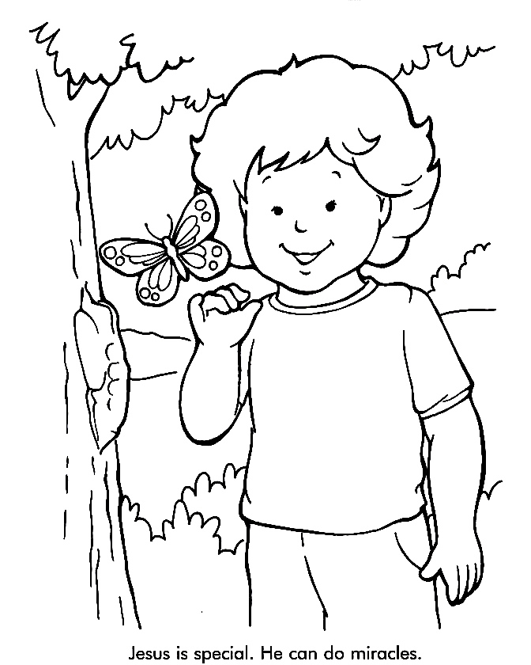

From Thru-the-Bible Coloring Pages for Ages 4-8. © 1986,1988 Standard
Publishing. Used by permission. Reproducible Coloring Books may be
purchased from Standard Publishing, www.standardpub.com

