Spiral puzzle

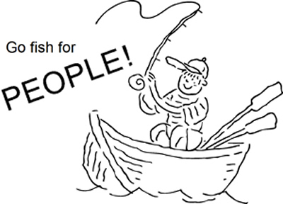
Copyright © Sermons4Kids.com
May be reproduced for Ministry Use
Children’s Worship Bulletin

What a Catch!

Luke 5:1-11

Word search puzzle

St. Paul’s UCC
301 W. Penn Avenue
Robesonia, PA 19551
610-621-5770
Color me!

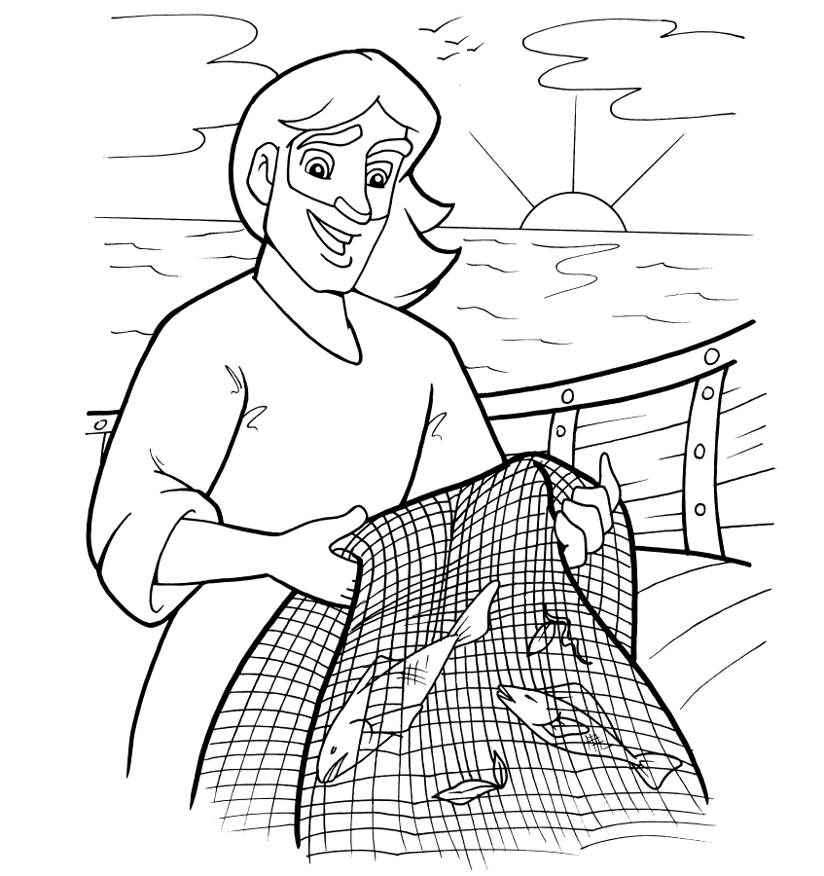
Then Jesus said to Simon, "Don't be afraid; from now on you will catch men." So they pulled their boats up on shore, left everything and followed him.
Luke 5:10-11

Decoder puzzle

Copyright © CalvaryCurriculum.com
Used by Permission

Decoder puzzle

