Looking at his disciples, he said: "Blessed are you who are poor, for yours is the kingdom of God.
Luke 6:20 (NIV)

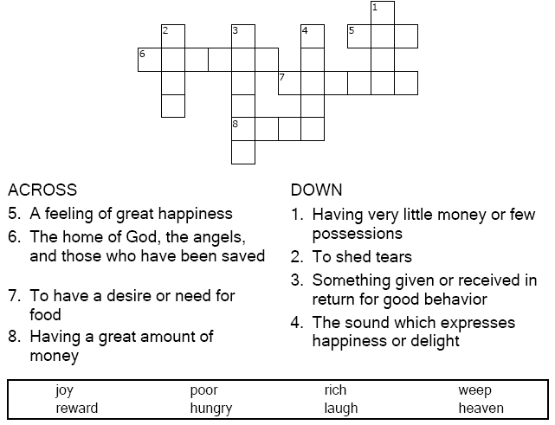



Copyright © Sermons4Kids, Inc.
May be reproduced for Ministry Use

Children’s Worship Bulletin

In Search of Happiness

Luke 6:17-26

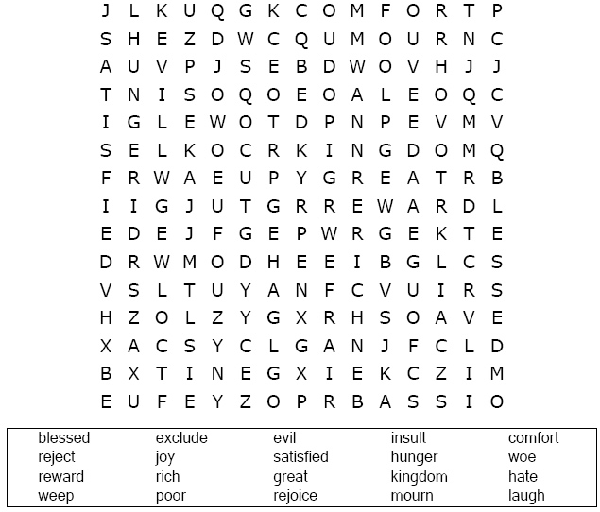

St. Paul’s UCC
301 W. Penn Avenue
Robesonia, PA 19551
610-621-5770

Look up Luke 6:20-23 in the Bible. Answers are
also in the box below the fill in the blanks quiz.

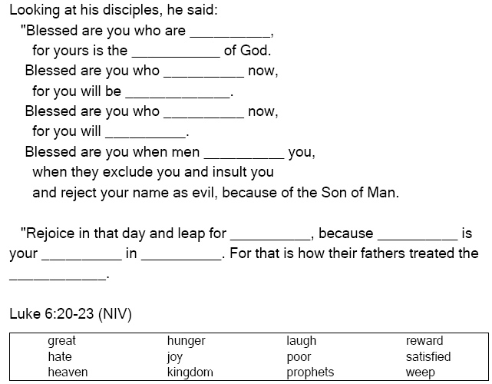

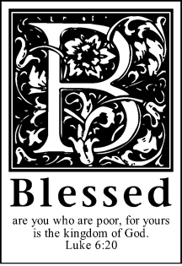

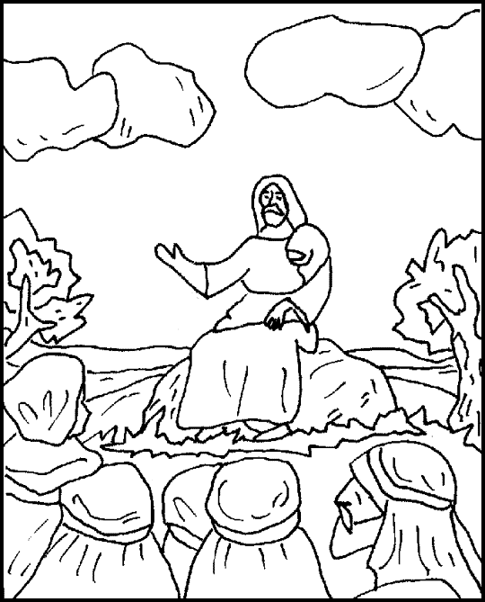

He went down with them and stood on a level place. A large
crowd of his disciples was there and a great number of
people from all over Judea, from Jerusalem, and
from the coast of Tyre and Sidon, who had
come to hear him and to be healed
of their diseases.
Luke 6:17-18 (NIV)

