
Copyright © Sermons4Kids, Inc.
May be reproduced for Ministry Use
Children’s Worship Bulletin

The Transfiguration

Luke 9:28-36

St. Paul’s UCC
301 W. Penn Avenue
Robesonia, PA 19551
610-621-5770

Can you find the way to Jesus, Moses,
and Elijah on the mountain?



Two men, Moses and Elijah, appeared in glorious splendor, talking with Jesus.
Luke 9:30 (NIV)

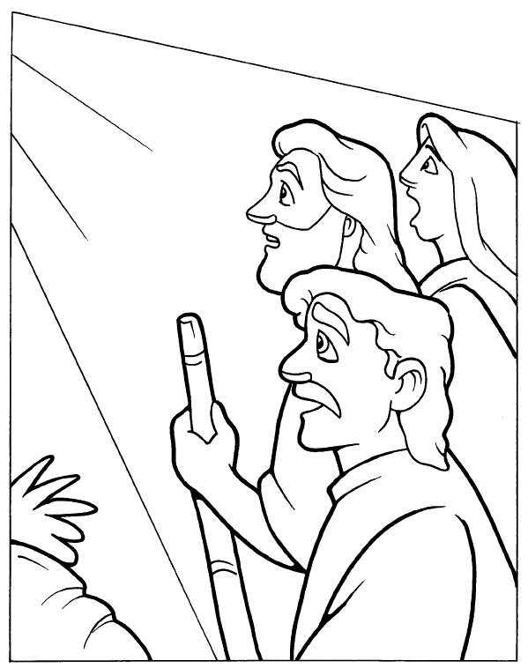
The Transfiguration

Copyright © CalvaryCurriculum.com
Used by Permission

