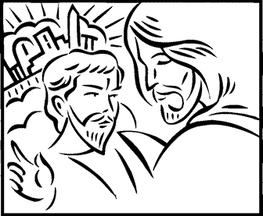

Copyright © Sermons4Kids, Inc.
May be reproduced for Ministry Use
Children’s Worship Bulletin

The Temptation of Christ

Luke 4:1-13

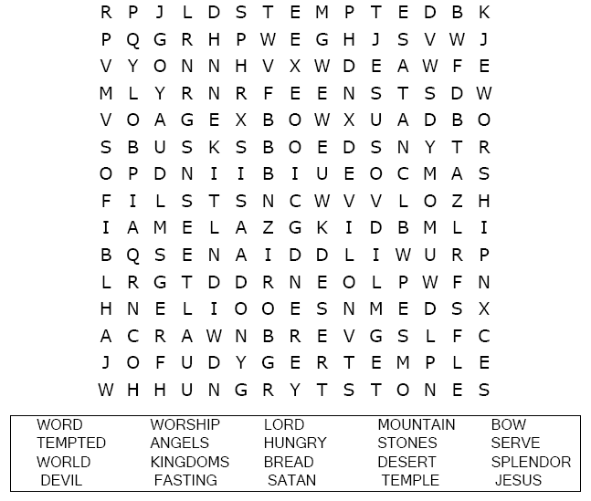
St. Paul’s UCC
301 W. Penn Avenue
Robesonia, PA 19551
610-621-5770

Choose the word that best matches the definition
.
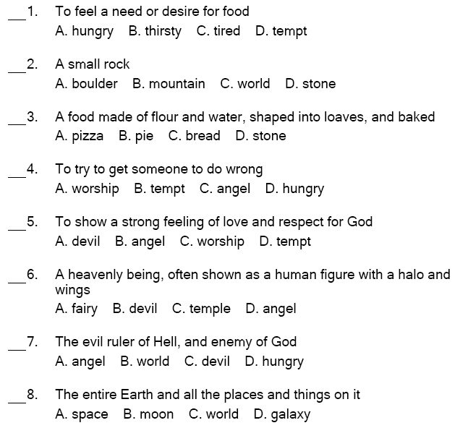
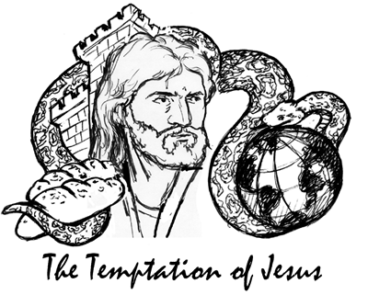

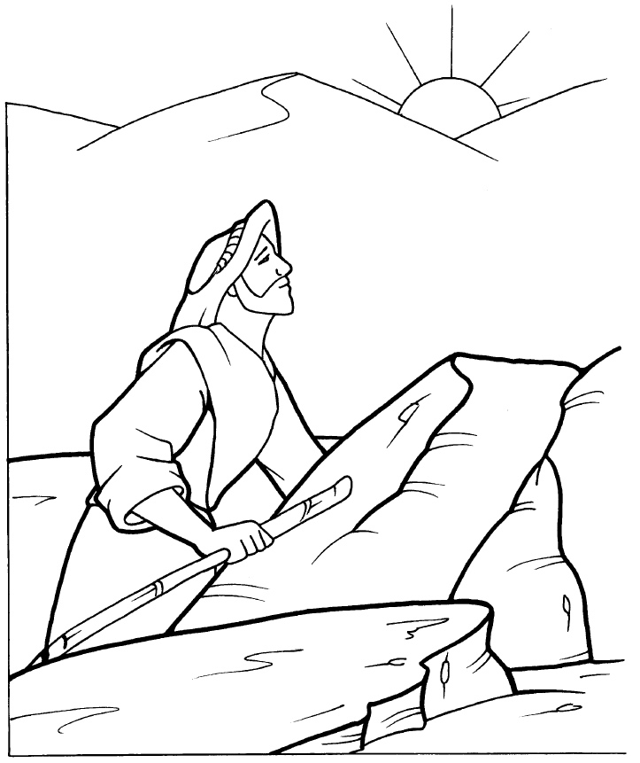
The Temptation of Jesus

Copyright © CalvaryCurriculum.com
Used by Permission

