Crossword puzzle

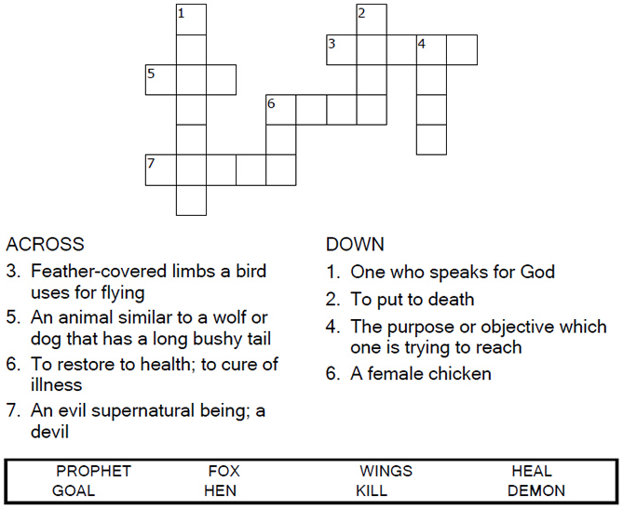
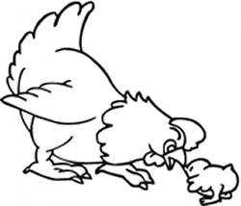
Copyright © Sermons4Kids, Inc.
May be reproduced for Ministry Use

Children’s Worship Bulletin

Jesus Weeps for Jerusalem

Luke 3:31-35

Word search puzzle

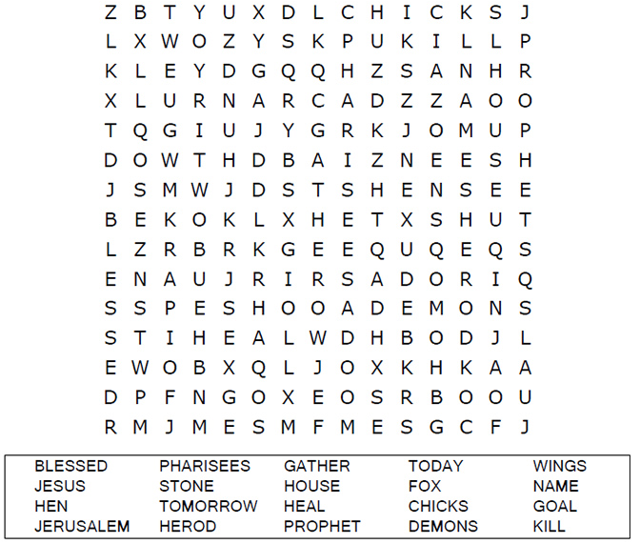
St. Paul’s UCC
301 W. Penn Avenue
Robesonia, PA 19551
610-621-5770

Coloring page

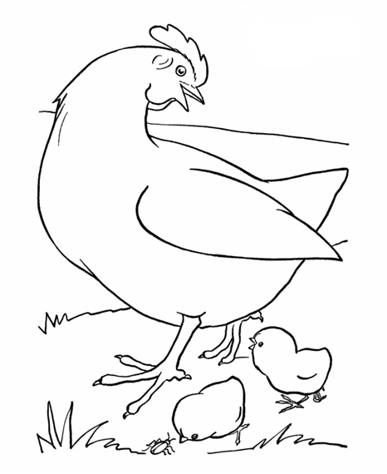

Maze puzzle

Help the chicks find their way back to the mother hen.
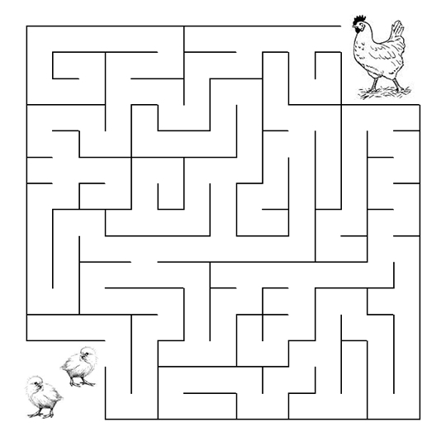
"O Jerusalem, Jerusalem, you who kill the prophets and
stone those sent to you, how often I have longed to gather
your children together, as a hen gathers her chicks under
her wings, but you were not willing!"
Luke 13:34 (NIV)

