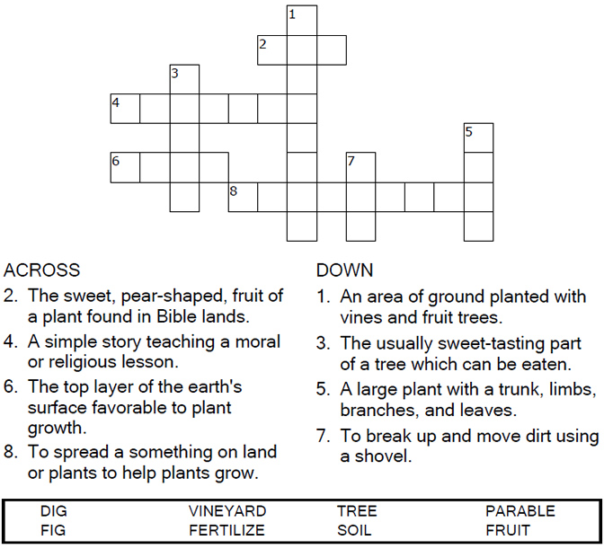

Copyright © Sermons4Kids, Inc.
May be reproduced for Ministry Use

Children’s Worship Bulletin

Bearing Good Fruit

Luke 13:1-9

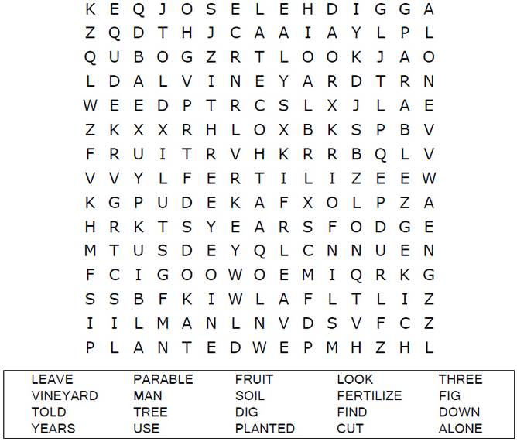
St. Paul’s UCC
301 W. Penn Avenue
Robesonia, PA 19551
610-621-5770

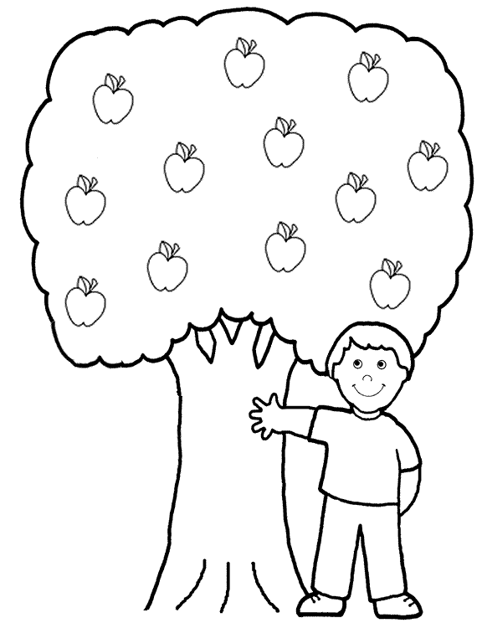
God wants us to bear good fruit!

Connect the dots to complete the picture.
