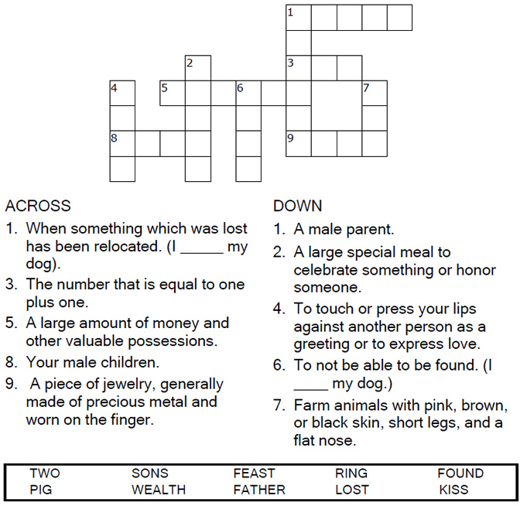

Copyright © Sermons4Kids, Inc.
May be reproduced for Ministry Use

Children’s Worship Bulletin

The Prodigal Son

Luke 15:11-32

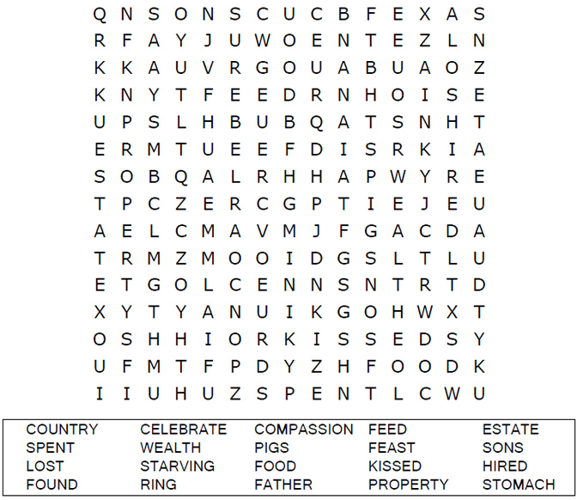
St. Paul’s UCC
301 W. Penn Avenue
Robesonia, PA 19551
610-621-5770

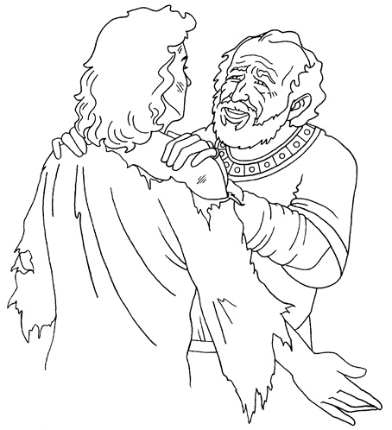
Jesus told the parable of the prodigal son.
Luke 15:11-32
Copyright © CalvaryCurriculum.com
Used by Permission

Connect the dots to complete the picture.
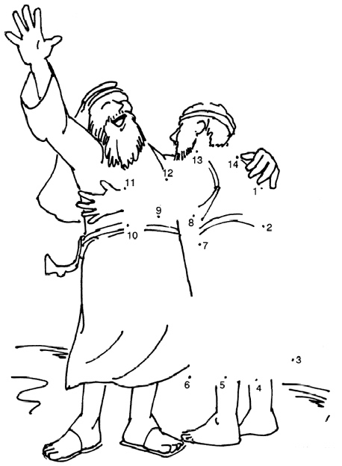
Copyright © Church of God International
Used by Permission

