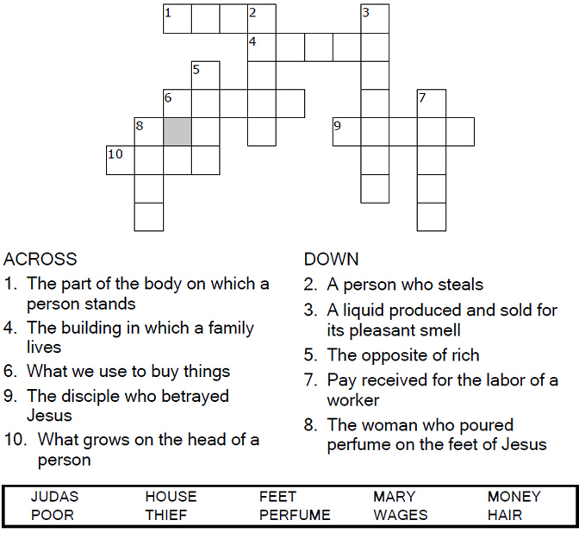
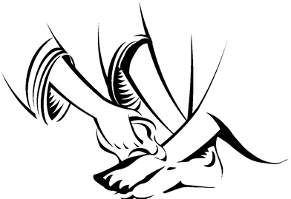
Copyright © Sermons4Kids, Inc.
May be reproduced for Ministry Use

Children’s Worship Bulletin

Mary Anoints the Feet of Jesus

John 12:1-8

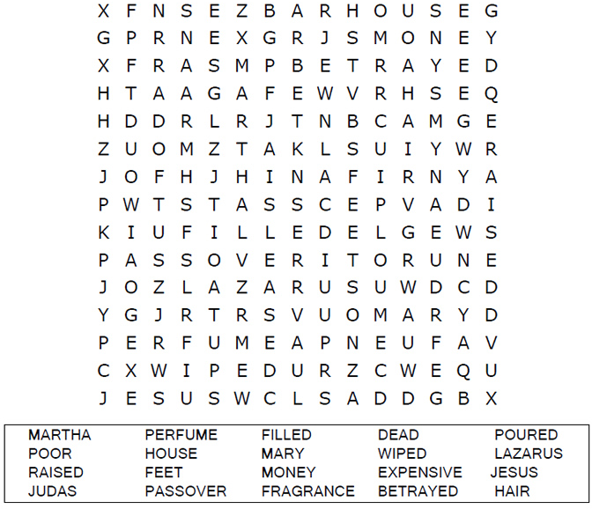
St. Paul’s UCC
301 W. Penn Avenue
Robesonia, PA 19551
610-621-5770

Connect the dots to complete the picture.

Then Mary took about a pint of pure nard, an
expensive perfume; she poured it on Jesus'
feet and wiped his feet with her hair.
John 12:3a (NIV))

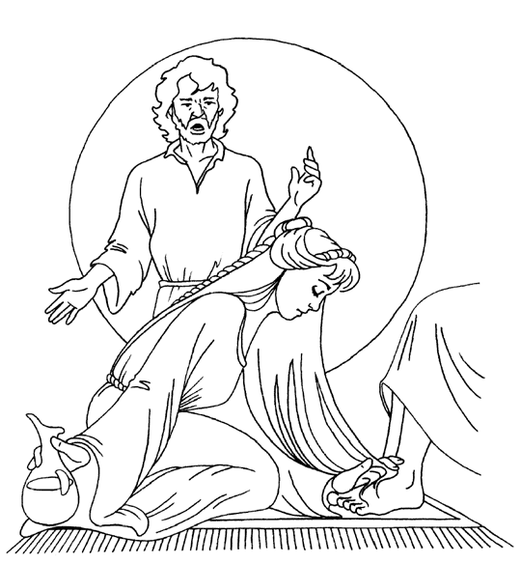
Mary Anoints Jesus’ Feet
John 12:1-8

Copyright © CalvaryCurriculum.com
Used by Permission

