
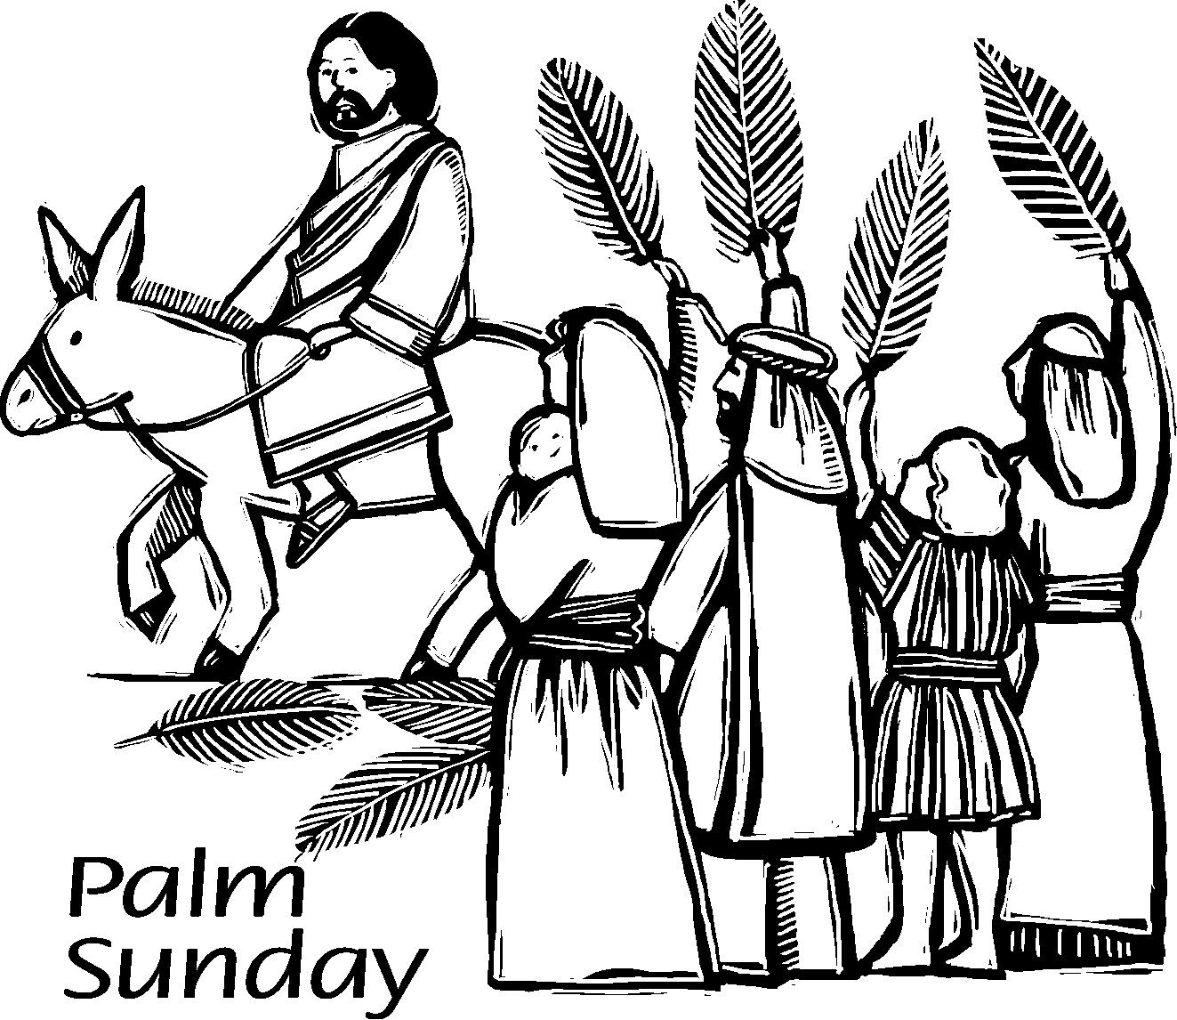
Copyright © Sermons4Kids, Inc.
May be reproduced for Ministry Use

Children’s Worship Bulletin

Palm Sunday

Luke 19:28-40

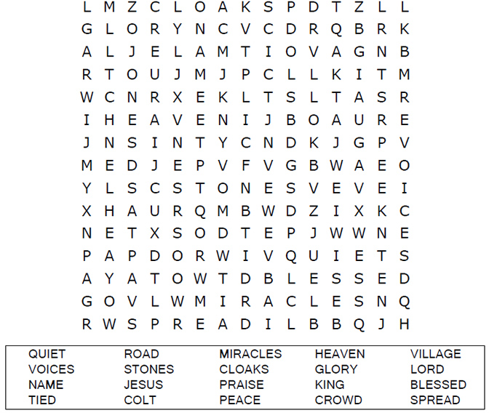
St. Paul’s UCC
301 W. Penn Avenue
Robesonia, PA 19551
610-621-5770

Join Jesus on the road to Jerusalem.


When he came near the place where the ______ goes down the
Mount of Olives, the whole _______ of disciples began joyfully to
_______ God in loud voices for all the _______ they had seen.
“Blessed is the _____ who comes in the ______ of the Lord!”
” _______ in heaven and _______ in the highest!”
Luke 19:37-38 (NIV)
Word Bank
Peace road praise glory
King crowd miracles name


The Triumphal Entry

Copyright © CalvaryCurriculum.com
Used by Permission

