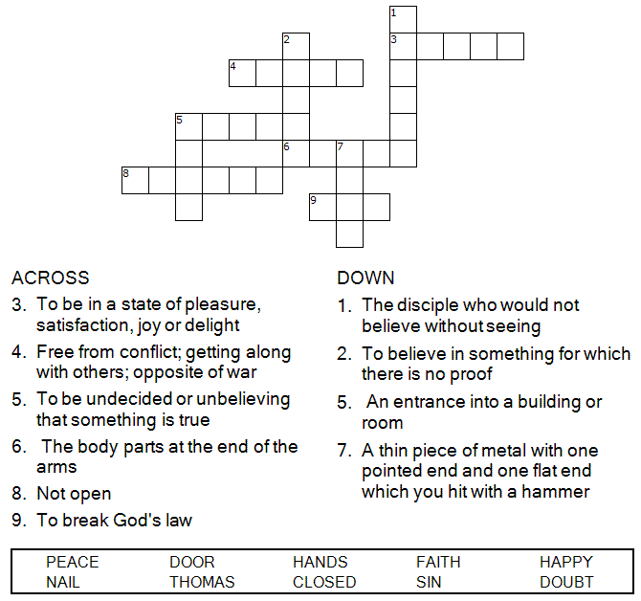

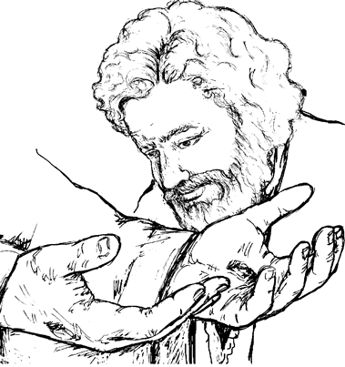

Copyright © Sermons4Kids, Inc.
May be reproduced for Ministry Use
Children’s Worship Bulletin

Doubting Thomas

John 20:19-31

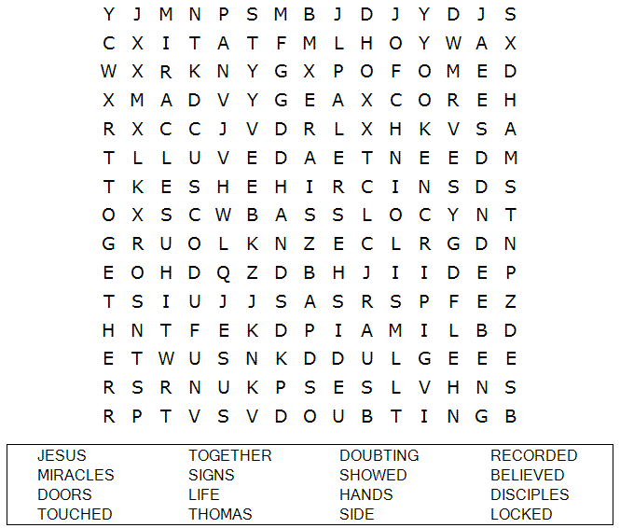

St. Paul’s UCC
301 W. Penn Avenue
Robesonia, PA 19551
610-621-5770

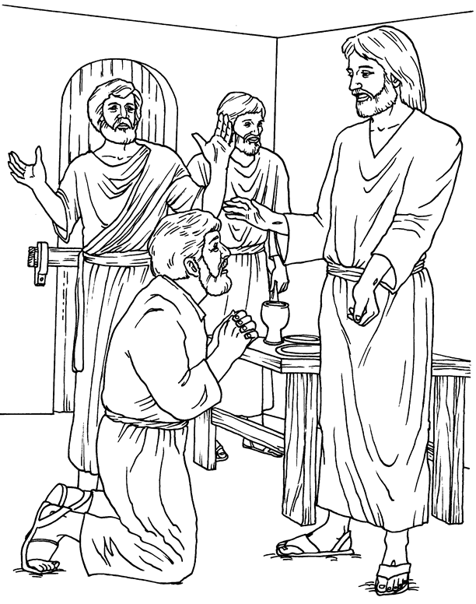
Jesus Appears!

From BibleStoryCard Learning System(tm) Coloring Book © 1996 Wesleyan
Publishing House. Used by permission. Additional BibleStoryCard resources
are available by calling 1-800-493-7539 or visiting online
http://www.wphonline.com

Stop doubting and believe!



