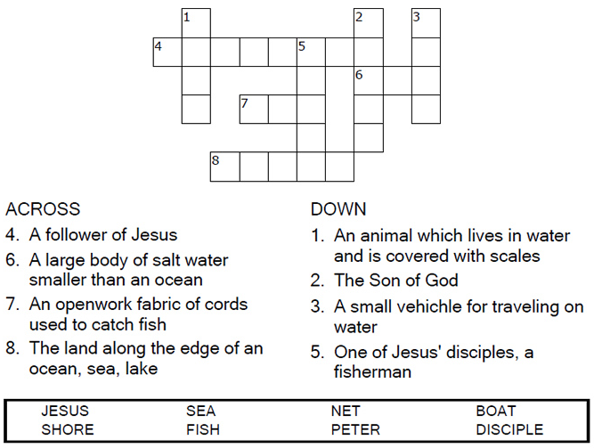
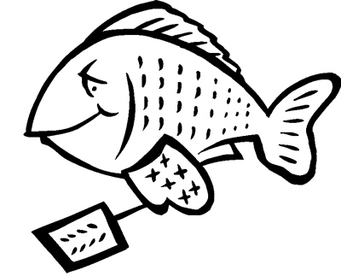
Copyright © Sermons4Kids, Inc.
May be reproduced for Ministry Use

Children’s Worship Bulletin

Breakfast on the Beach

John 21:1-14

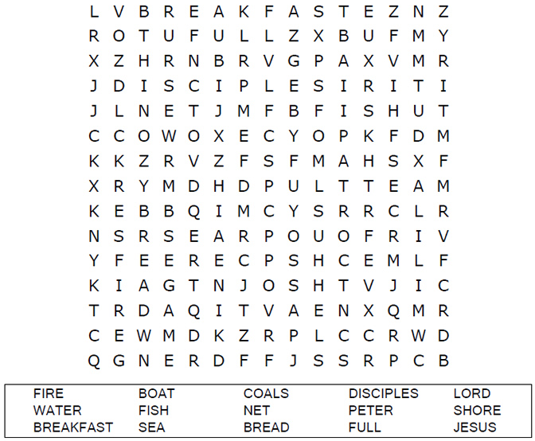
St. Paul’s UCC
301 W. Penn Avenue
Robesonia, PA 19551
610-621-5770

Connect the dots to complete the picture.

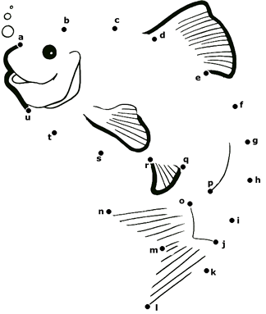

He called out to them, "Friends, haven't you any fish?"
"No," they answered.
John 21:5-6 (NIV)

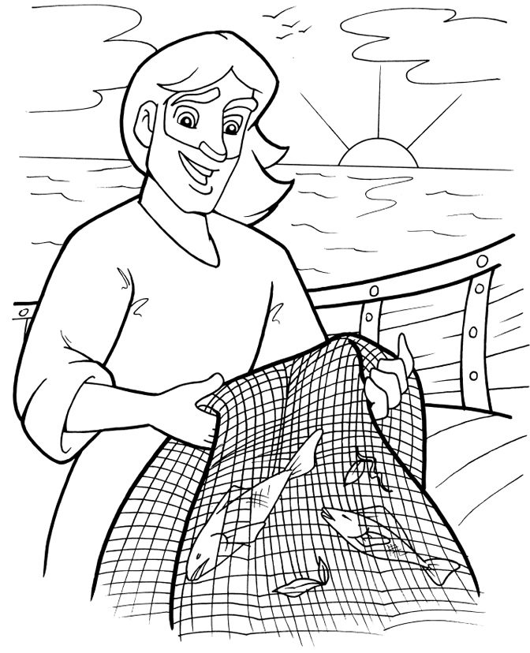
Jesus Helps Catch Fish

Copyright © CalvaryCurriculum.com
Used by Permission

