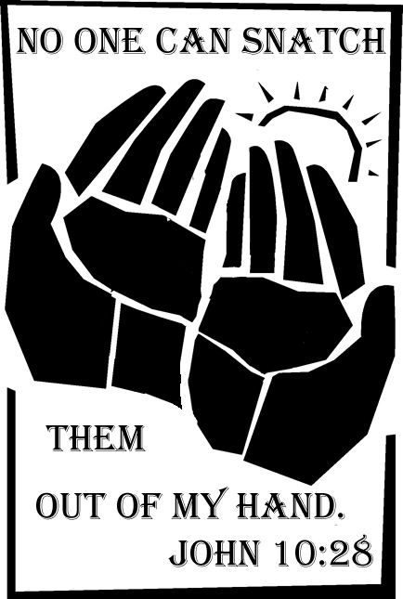
Copyright © Sermons4Kids, Inc.
May be reproduced for Ministry Use

Children’s Worship Bulletin

Guaranteed Forever

John 10:27-30

St. Paul’s UCC
301 W. Penn Avenue
Robesonia, PA 19551
610-621-5770

The words below have been written in code. Use the hints in
the decoder at the top of the page to help break the code.



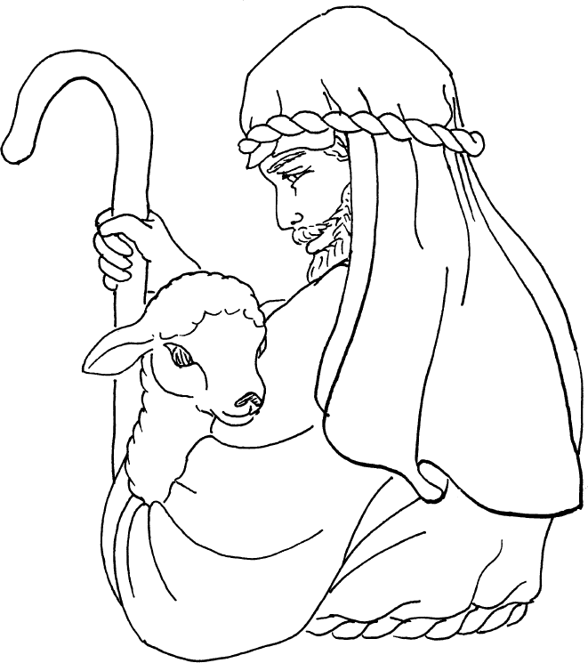

Copyright © CalvaryCurriculum.com
Used by permission.

